Common Worship Psalm 91.1-2,9-16 Chant: Rev. R.B. Earée

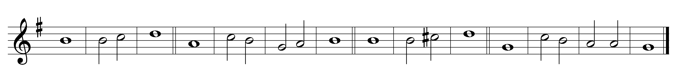

1 Whoever dwells in the shelter of the | Most | High *
and abides under the | shadow | of the · Al- | mighty,

2 Shall say to the Lord, ‘My | refuge· and my | stronghold, *
my God, in | whom I | put my | trust.’

9 Because you have made the | Lord your | refuge *
and the Most | High | your | stronghold,

10 There shall no evil | happen· to | you, *
neither shall any | plague come | near your | tent.

11 For he shall give his angels charge | over | you, *
to keep you in | all | your | ways.

12 They shall bear you | in their | hands, *
lest you dash your | foot a- | gainst a | stone.

13 You shall tread upon the | lion· and | adder; *
the young lion and the serpent you shall | trample | under- | foot.

14 Because they have set their love upon me,
therefore will | I de-| liver them; *
I will lift them up, be- | cause they | know my | name.

15 They will call upon me and I will | answer | them; *
I am with them in trouble,
I will deliver them and | bring | them to | honour.

16 With long life will I | satis-| fy them; *
and | show them | my sal- | vation.

Words taken from Common Worship © The Archbishops’ Council 2000.

