*Common Worship Psalm 8 Chant: F.A.G. Ouseley*

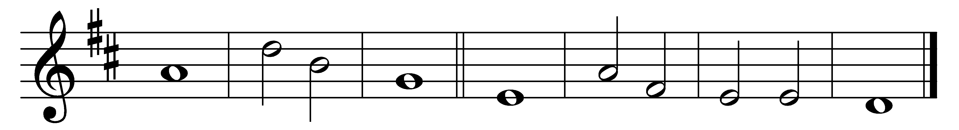

*O* | *Lord our* | *governor,*

*how glorious is your* | *name in* | *all the* | *world!*

2    Your majesty above the | heavens· is | praised

out of the | mouths of | babes· at the | breast.

3    You have founded a stronghold a-| gainst your | foes,

that you might still the | enem-· y | and the· a-| venger.

4    When I consider your heavens, the | work of· your | fingers,

the moon and the | stars that | you have· or-| dained,

5    What is man, that you should be | mindful· of | him;

the son of man, that | you should | seek him | out?

6    You have made him little | lower· than the | angels

and | crown him· with | glory· and | honour.

7    You have given him dominion over the | works of· your | hands

and put | all things | under· his | feet,

8    All | sheep and | oxen,

even the | wild | beasts· of the | field,

9    The birds of the air, the | fish· of the | sea

and whatsoever | moves· in the | paths· of the | sea.

10  *O* | *Lord our* | *governor,*

*how glorious is your* | *name in* | *all the* | *world!*

Words taken from Common Worship © The Archbishops’ Council 2000.