Psalm 51 – Common Worship

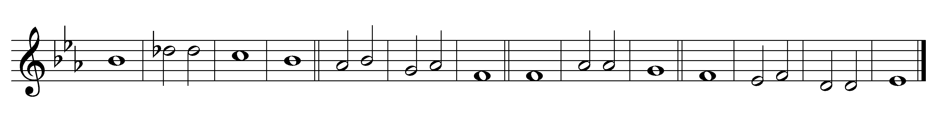

1 Have mercy on me, O God, in | your great | goodness;
according to the abundance of your compassion | blot out | my of-| fences.

2 Wash me thoroughly | from my | wickedness
and | cleanse me | from my | sin.

3 For I ac-| knowledge· my | faults
and my | sin is | ever· be-| fore me.

4 Against you only | have I | sinned
and done what is | evil | in your | sight,

5 So that you are justified | in your | sentence
and | righteous | in your | judgement.

6 I have been wicked even | from my | birth,
a | sinner· when my | mother· con-| ceived me.

7 Behold, you desire truth | deep with-| in me
and shall make me understand wisdom | in the | depths· of my | heart.

8 Purge me with hyssop and | I shall· be | clean;
wash me and | I shall· be | whiter· than | snow.

9 Make me hear of | joy and | gladness,
that the bones you have | broken | may re-| joice.

10 Turn your | face· from my | sins
and | blot out | all my· mis-| deeds.

11 Make me a clean | heart, O | God,
and re-| new a· right | spirit· with-| in me.

12 Cast me not a-| way· from your | presence
and take not your | holy | spirit | from me.

13 (2nd part) Give me again the joy of | your sal-| vation
and sustain me | with your | gracious | spirit.

Words taken from Common Worship © The Archbishops’ Council 2000.

