Psalm 45, 10-17 – Common Worship

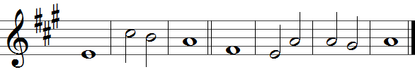

10 Hear, O daughter; consider and in -| cline your | ear;
forget your own people | and your | father’s | house.

11 So shall the king have pleasure | in your | beauty;
he is your | lord, so | do him | honour.

12 The people of Tyre shall | bring you | gifts;
the richest of the | people · shall | seek your | favour.

13 The king’s daughter is all | glorious · wi -| thin;
her clothing is em -| broidered | cloth of | gold.

14 She shall be brought to the king in | raiment · of | needlework;
after her the | virgins · that | are her · com -| panions.

15 With joy and gladness shall | they be | brought
and enter into the | palace | of the | king.

16 ‘Instead of your fathers | you shall · have | sons
whom you shall make princes | over | all the | land.

17 ‘I will make your name to be remembered through all | gene -| rations;
therefore shall the peoples | praise you · for | ever · and | ever.’

Words taken from Common Worship © The Archbishops’ Council 2000.

