Psalm 14

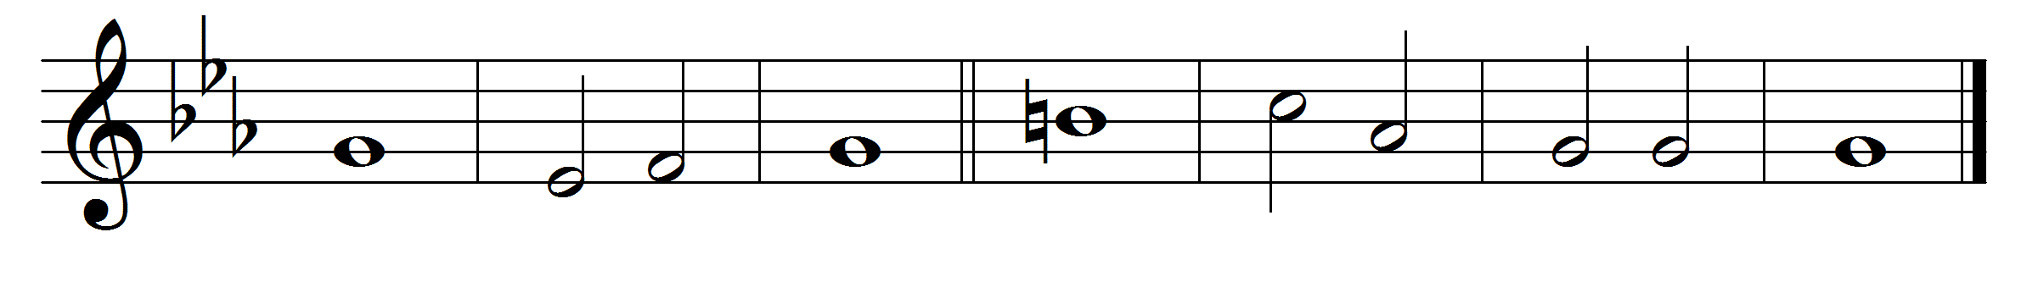

1 The fool has said in his heart, ‘There | is no | God.’ *
Corrupt are they, and abominable in their wickedness; there is | no one | that does | good.

2 The Lord has looked down from heaven upon the | children · of | earth, *
to see if there is anyone who is wise and | seeks | after | God.

3 But every one has turned back; all alike have be | - come cor | - rupt: *
there is none that does good; | no, | not | one.

4 Have they no knowledge, those |evil | - doers, *
who eat up my people as if they ate bread and do not |call up | - on the | Lord?

5 There shall they | be in · great | fear; *
for God is in the | compa · - ny | of the | righteous.

6 Though they would confound the | counsel · of the | poor, *
yet the | Lord shall | be their | refuge.

7 O that Israel’s salvation would | come out · of | Zion! *
When the Lord restores the fortunes of his people, then will Jacob re | - joice and | Israel · be | glad.

Words taken from Common Worship © The Archbishops’ Council 2000.

