Psalm 114 – Common Worship

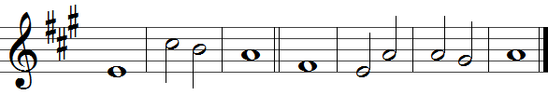

1 When Israel came | out of | Egypt,
the house of Jacob from a | people · of a | strange | tongue,

2 Judah be-| came his | sanctuary,
– | Israel | his do-| minion.

3 The sea saw | that, and | fled;
– | Jordan · was dri-| ven | back.

4 The mountains | skipped like | rams,
the little | hills like | young | sheep.

5 What ailed you, O sea, | that you | fled?
O Jordan, that | you were | driven | back?

6 You mountains, that you | skipped like | rams,
you little | hills like | young | sheep?

7 Tremble, O earth, at the | presence · of the | Lord,
at the presence | of the | God of | Jacob,

8 Who turns the hard rock into a | pool of | water,
the flint-stone | into · a | springing | well.

Words taken from Common Worship © The Archbishops’ Council 2000.

