At even, ere the sun was set AMNS 9 Melody: Angelus L.M.
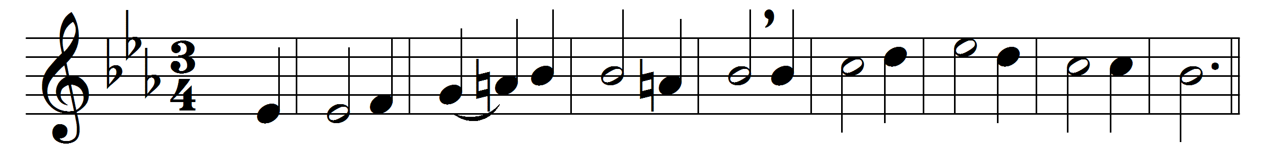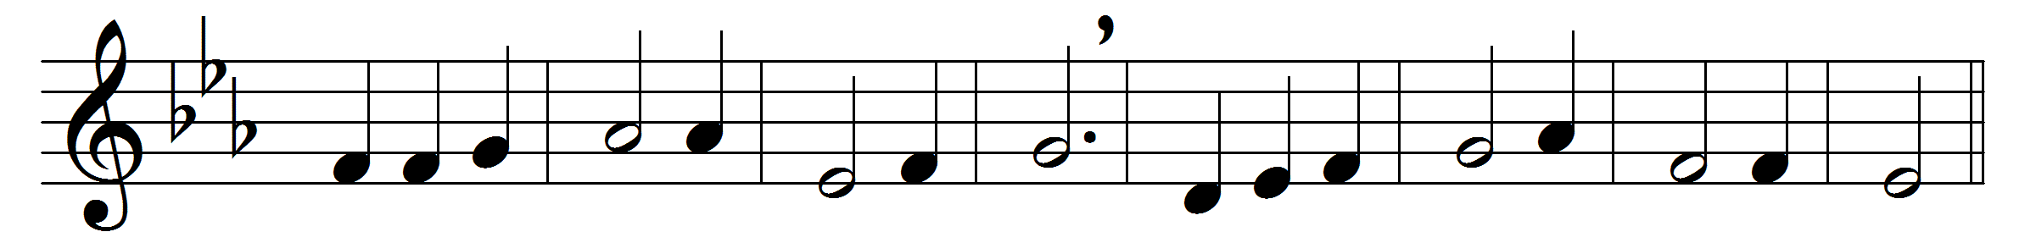

At even, ere the sun was set,
the sick, O Lord, around thee lay;
O in what divers pains they met!
O with what joy they went away!

Once more ’tis eventide, and we
oppressed with various ills draw near;
what if thy form we cannot see?
we know and feel that thou art here.

O Saviour Christ, our woes dispel;
for some are sick, and some are sad,
and some have never loved thee well,
and some have lost the love they had;

and some have found the world is vain,
yet from the world they break not free;
and some have friends who give them pain,
yet have not sought a friend in thee;

and none, O Lord, have perfect rest,
for none are wholly free from sin;
and they who fain would serve thee best
are conscious most of wrong within.

O Saviour Christ, thou too art man;
thou hast been troubled, tempted, tried;
thy kind but searching glance can scan
the very wounds that shame would hide.

Thy touch has still its ancient power;
no word from thee can fruitless fall:
hear, in this solemn evening hour,
and in thy mercy heal us all.

Words: Henry Twells (1823-1900)
Music: adapted from Georg Joseph (c. 1630-c. 1668)

