O God, our help in ages past AMNS 99 Melody: St. Anne C.M.
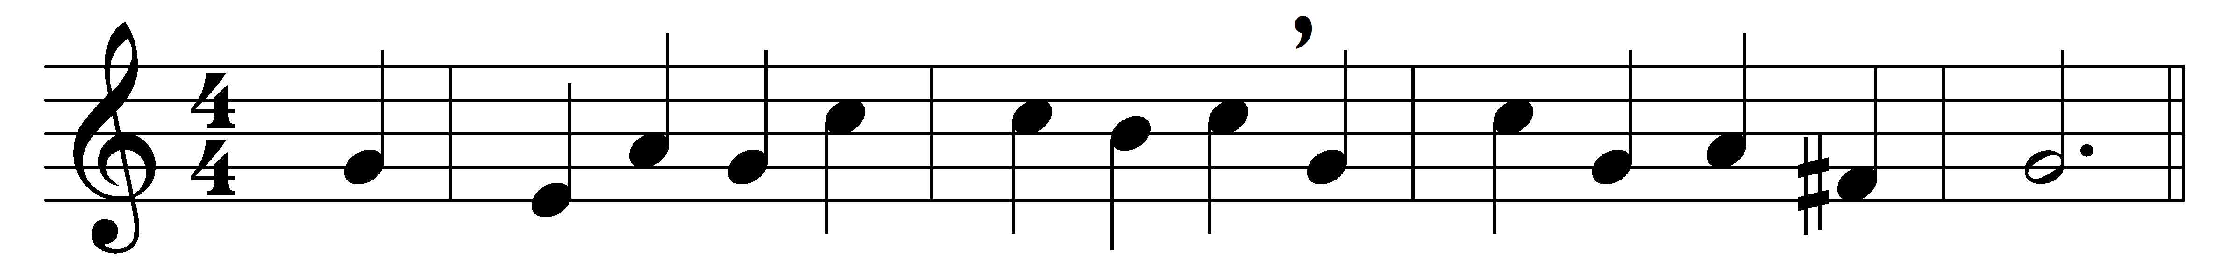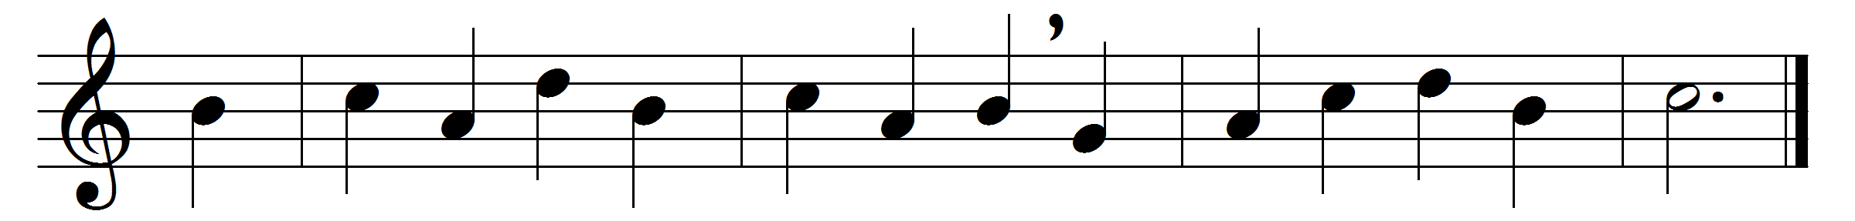

O God, our help in ages past,
our hope for years to come,
our shelter from the stormy blast,
and our eternal home;

beneath the shadow of thy throne
thy saints have dwelt secure;
sufficient is thine arm alone,
and our defence is sure.

Before the hills in order stood,
or earth received her frame,
from everlasting thou art God,
to endless years the same.

A thousand ages in thy sight
are like an evening gone;
short as the watch that ends the night
before the rising sun.

Time, like an ever-rolling stream,
bears all its sons away;
they fly forgotten, as a dream
dies at the opening day.

O God, our help in ages past,
our hope for years to come,
be thou our guard while troubles last,
and our eternal home.

Words: Isaac Watts (1674-1748)
Music: from the Supplement to the New Version, 1708

