From all that dwell below the skies AMNS 98
Melody: Lasst uns erfreuen (Easter Song) 8 8. 4 4. 8 8. and Alleluias
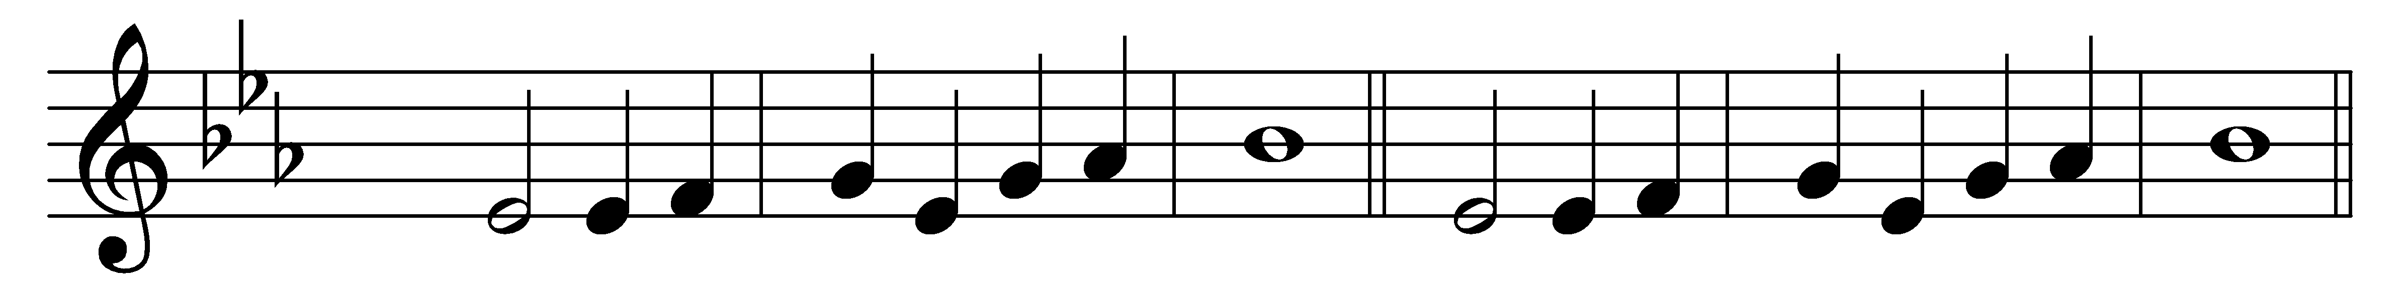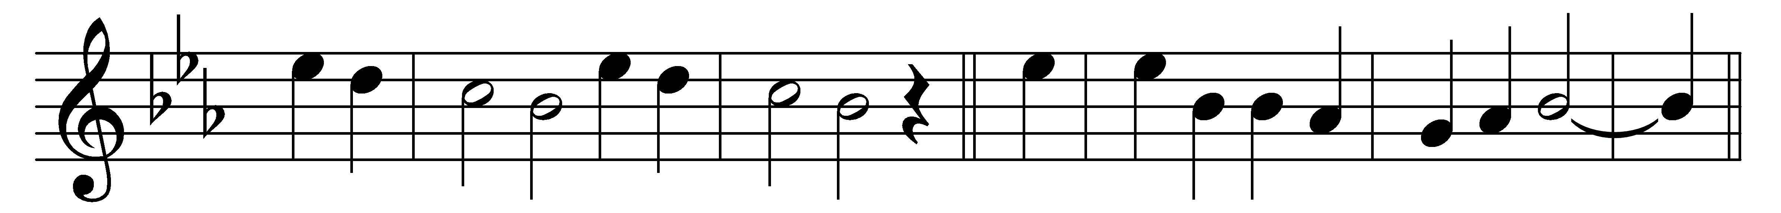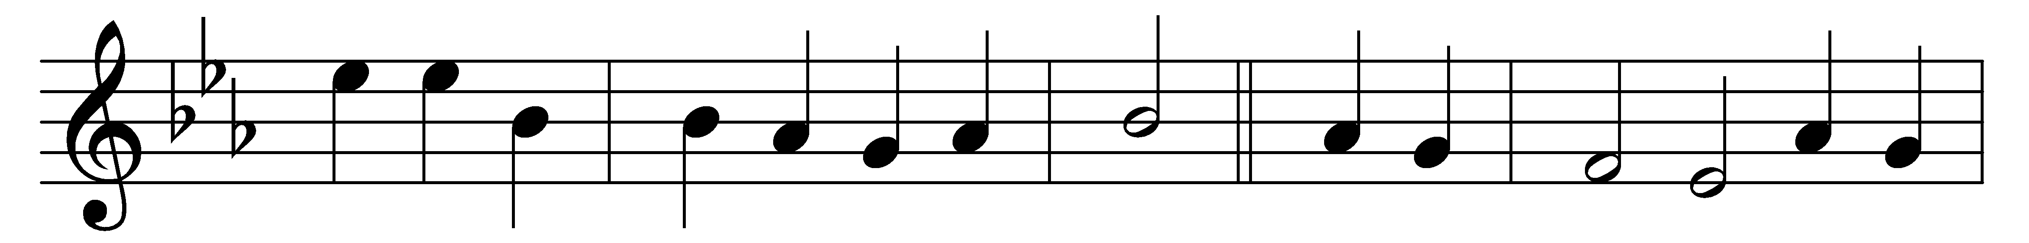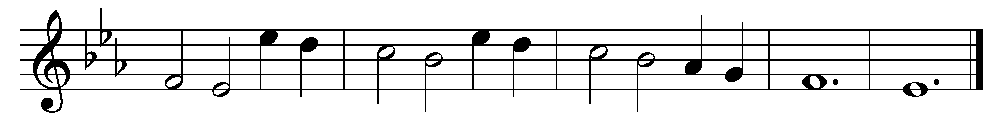

From all that dwell below the skies
let the Creator’s praise arise:
Alleluia.
let the Redeemer’s name be sung
through every land by every tongue.
Alleluia.
Eternal are thy mercies, Lord;
eternal truth attends thy word:
Alleluia.
thy praise shall sound from shore to shore,
till suns shall rise and set no more.
Alleluia.

Words: Isaac Watts (1674-1748)
Music: Melody from Geistliche Kirchengesäng, Cologne, 1623

