Father of heaven, whose love profound AMNS 97 Melody: St. Cross L.M.
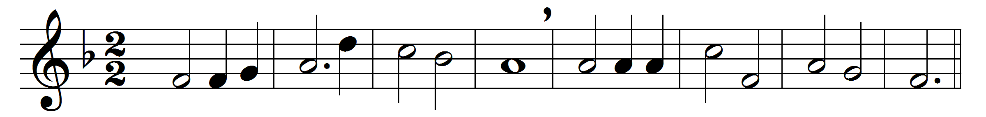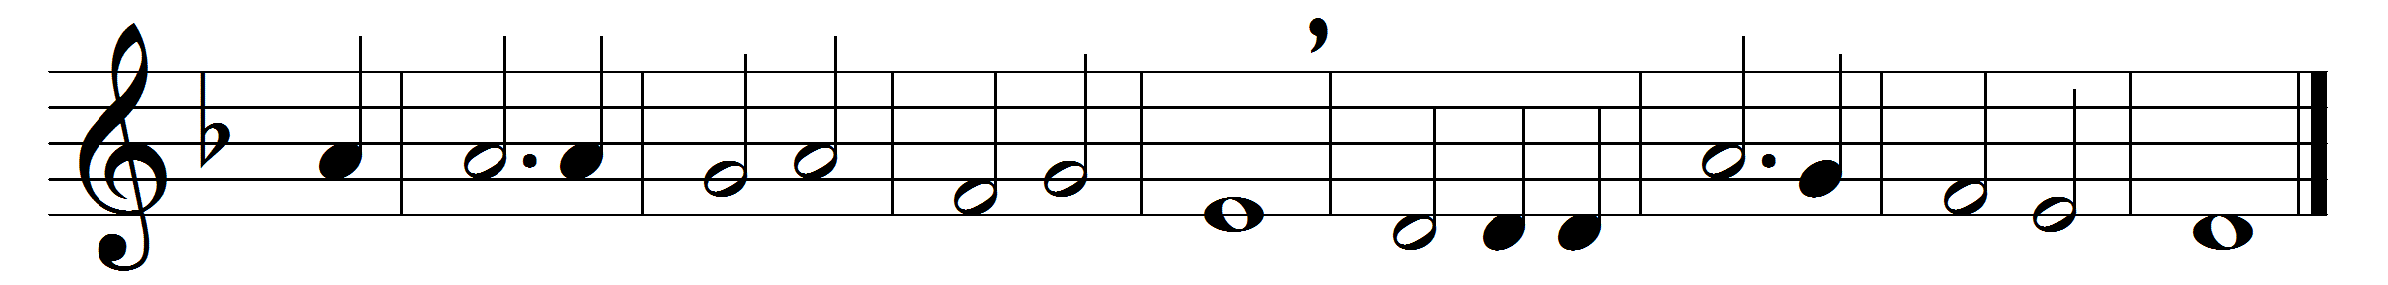

Father of heaven, whose love profound
a ransom for our souls hath found,
before thy throne we sinners bend,
to us thy pardoning love extend.

Almighty Son, incarnate Word,
our Prophet, Priest, Redeemer, Lord,
before thy throne we sinners bend,
to us thy saving grace extend.
Eternal Spirit, by whose breath
the soul is raised from sin and death,
before thy throne we sinners bend,
to us thy quickening power extend.
Thrice Holy! Father, Spirit, Son;
mysterious Godhead, Three in One,
before thy throne we sinners bend,
grace, pardon, life to us extend.

Words: Edward Cooper (1770-1833)
Music: John Bacchus Dykes (1823-1876)

