Father most holy AMNS 94 Melody: Chartres (Angers) 11 11 11. 5.
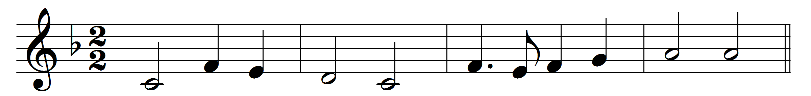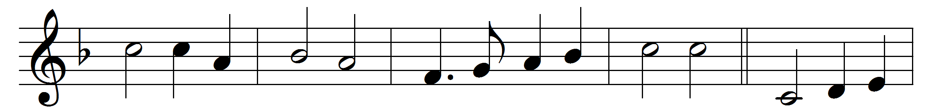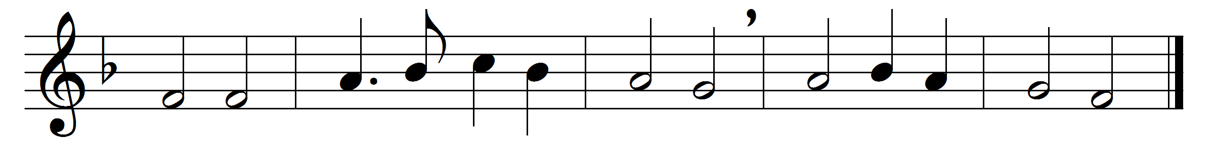

Father most holy, merciful and loving,
Jesu, Redeemer, ever to be worshipped,
life-giving Spirit, Comforter most gracious,
God everlasting;
Three in a wondrous Unity unbroken,
One perfect Godhead, love that never faileth,
light of the angels, succour of the needy,
hope of all living;
All thy creation serveth its Creator,
thee every creature praiseth without ceasing;
we too would sing thee psalms of true devotion:
hear, we beseech thee.
Lord God Almighty, unto thee be glory,
One in three Persons, over all exalted.
Thine, as is meet, be honour, praise and blessing
now and for ever.

Words: Latin, before 10th century, translated by Alfred Edward Alston (1862-1927)
Music: Melody from Chartres Antiphoner, 1784

