Come, thou Holy Spirit, come AMNS 92 Melody: Veni, sancte Spiritus 7 7 7. D.
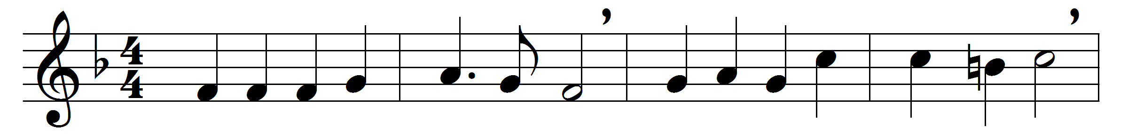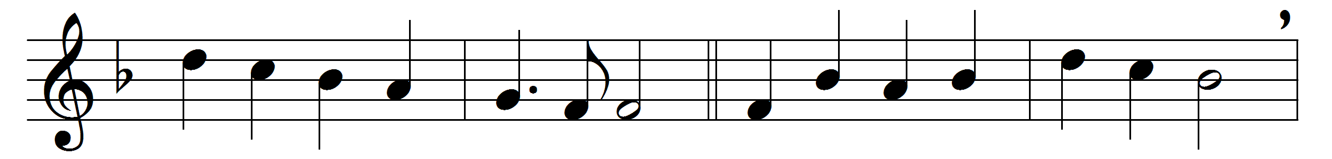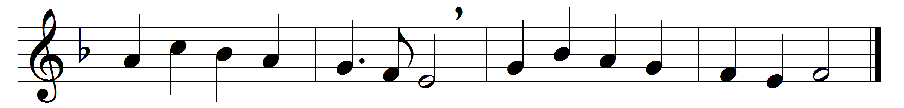

Come, thou Holy Spirit, come,
and from thy celestial home
shed a ray of light divine;
come, thou Father of the poor,
come, thou source of all our store,
come, within our bosoms shine:

Thou of comforters the best,
thou the soul’s most welcome guest,
sweet refreshment here below;
in our labour rest most sweet,
grateful coolness in the heat,
solace in the midst of woe.

O most blessèd Light divine,
shine within these hearts of thine,
and our inmost being fill;
where thou art not, man hath naught,
nothing good in deed or thought,
nothing free from taint of ill.

Heal our wounds; our strength renew;
on our dryness pour thy dew;
wash the stains of guilt away;
bend the stubborn heart and will;
melt the frozen, warm the chill;
guide the steps that go astray.

On the faithful, who adore
and confess thee, evermore
in thy sevenfold gifts descend:
give them virtue’s sure reward,
give them thy salvation, Lord,
give them joys that never end.

Words: Stephen Langton (d. 1228), translated by Edward Caswall (1814-1878)
Music: Melody by Samuel Webbe the elder (1740-1816)

