When God of old came down from heaven AMNS 90 Melody: Winchester Old C.M.
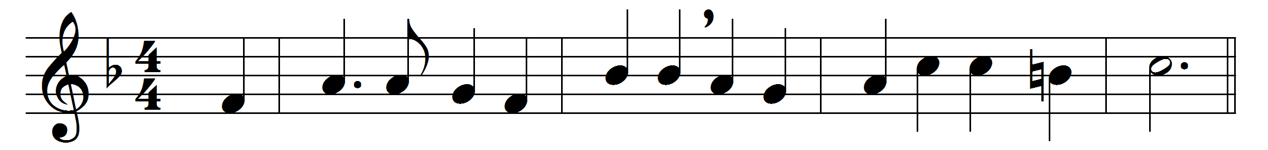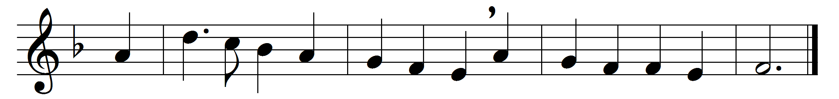

When God of old came down from heaven,
in power and wrath he came;
before his feet the clouds were riven,
half darkness and half flame.
But when he came the second time,
he came in power and love;
softer than gale at morning prime
hovered his holy Dove.
The fires, that rushed on Sinai down
in sudden torrents dread,
now gently light, a glorious crown,
on every sainted head.
And as on Israel’s awestruck ear
the voice exceeding loud,
the trump that angels quake to hear,
thrilled from the deep, dark cloud;
So, when the Spirit of our God
came down his flock to find,
a voice from heaven was heard abroad,
a rushing, mighty wind.
It fills the Church of God; it fills
the sinful world around:
only in stubborn hearts and wills
no place for it is found.
Come, Lord, come Wisdom, Love, and Power,
open our ears to hear;
let us not miss the accepted hour:
save, Lord, by love or fear.

Words: John Keble (1792-1866)
Music: Melody from T. Este (Psalms, 1592)

