Hail, gladdening Light, of his pure glory poured AMNS 8 Melody: Sebaste Irregular metre

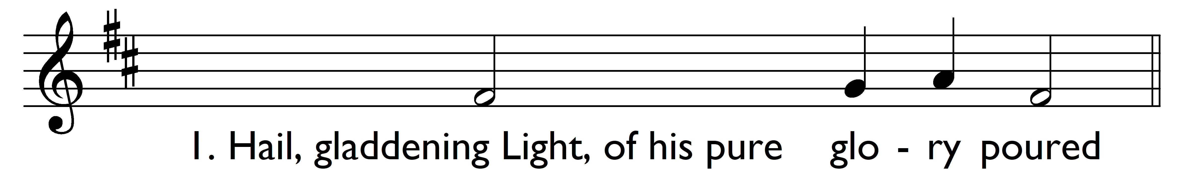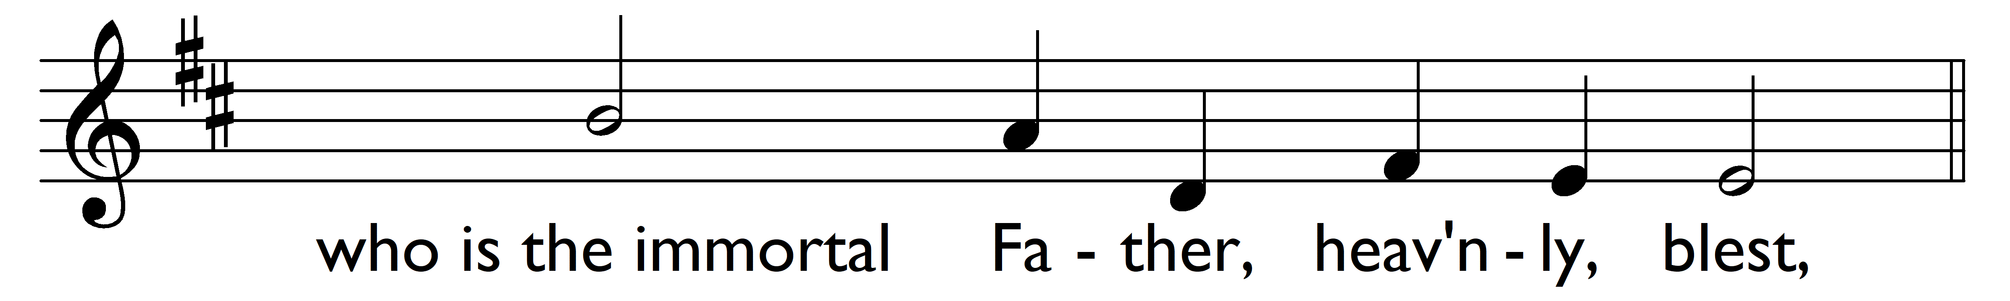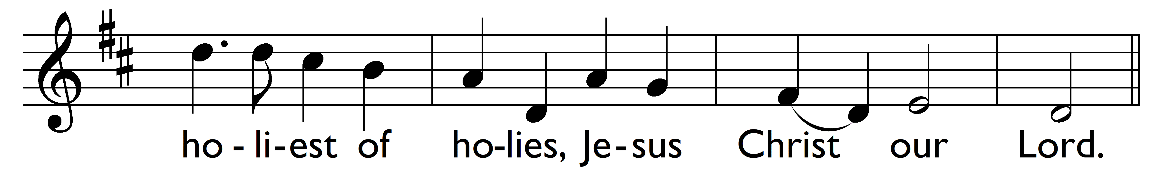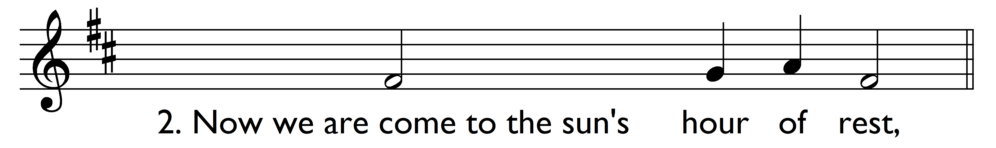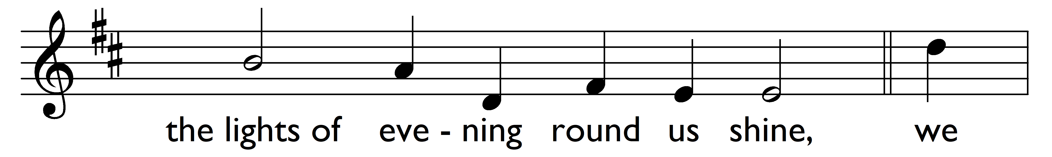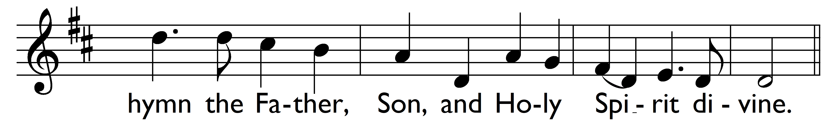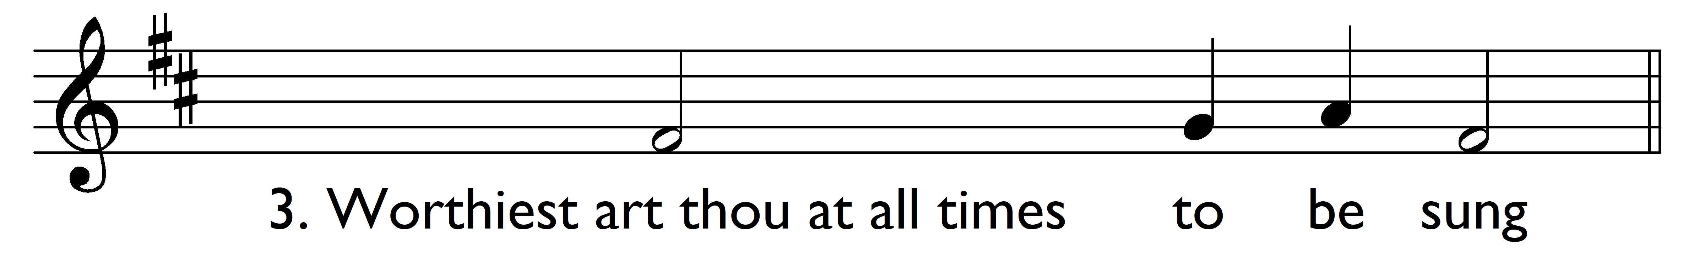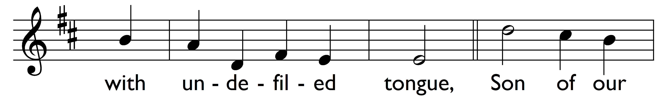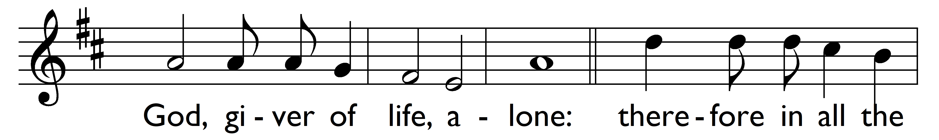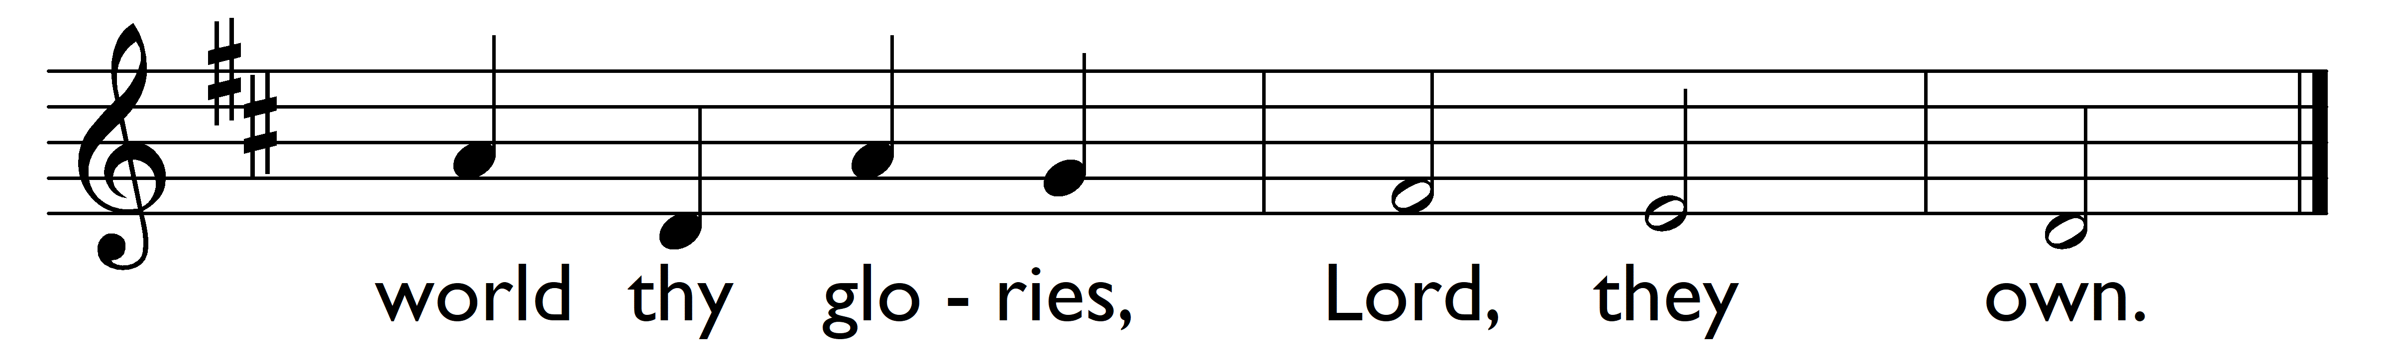

Words: Greek (3rd century or earlier), translated by John Keble (1792-1866)
Music: John Stainer (1840-1901)

