See the Conqueror mounts in triumph AMNS 88 Melody: Rex Gloriae 8 7. 8 7. D.
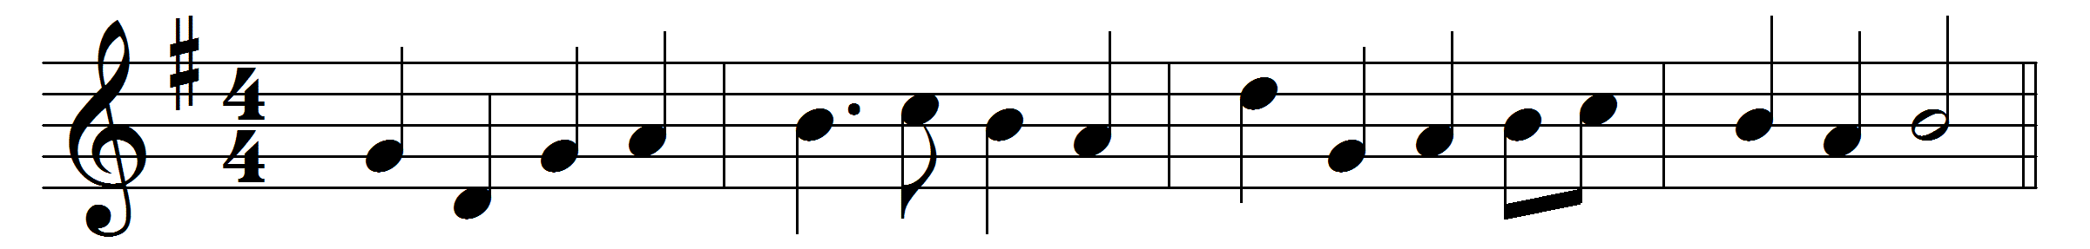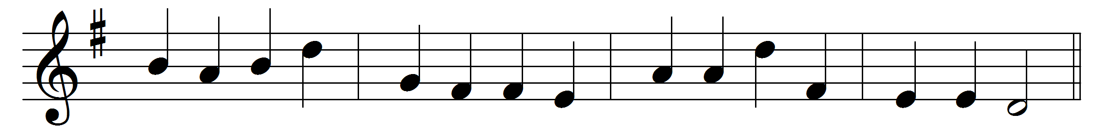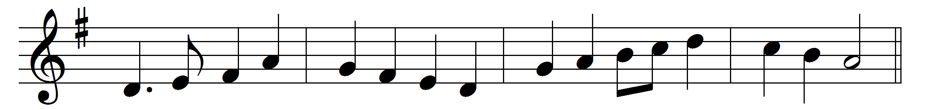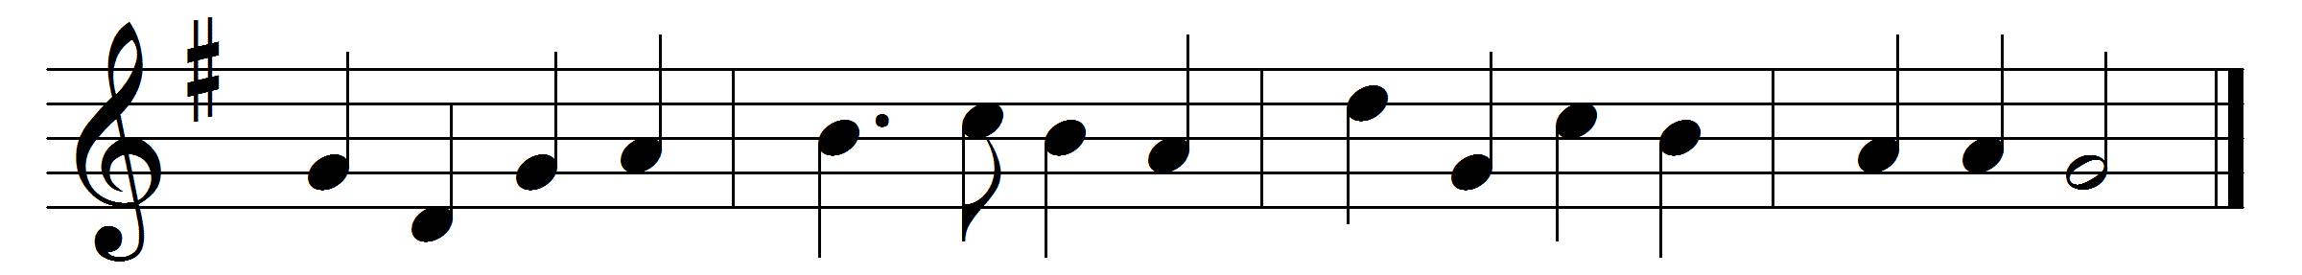
See the Conqueror mounts in triumph,
see the King in royal state
riding on the clouds his chariot
to his heavenly palace gate;
hark, the choirs of angel voices
joyful alleluias sing,
and the portals high are lifted
to receive their heavenly King.

Who is this that comes in glory,
with the trump of jubilee?
Lord of battles, God of armies,
he has gained the victory;
he who on the Cross did suffer,
he who from the grave arose,
he has vanquished sin and Satan,
he by death has spoiled his foes.

He has raised our human nature
on the clouds to God’s right hand;
there we sit in heavenly places,
there with him in glory stand:
Jesus reigns, adored by angels;
man with God is on the throne;
mighty Lord, in thine ascension
we by faith behold our own.

See him who is gone before us
heavenly mansions to prepare,
see him who is ever pleading
for us with prevailing prayer,
see him who with sound of trumpet
and with his angelic train,
summoning the world to judgement,
on the clouds will come again.

Glory be to God the Father;
glory be to God the Son,
dying, ris’n, ascending for us,
who the heavenly realm has won;
glory to the Holy Spirit
to One God in Persons Three
glory both in earth and heaven,
glory, endless glory be.

Words: Christopher Wordsworth (1807-1885)
Music: Henry Smart (1813-1879)

