Hail the day that sees him rise AMNS 87 Melody: Orientis Partibus 7 7. 7 7.
AMR version of tune
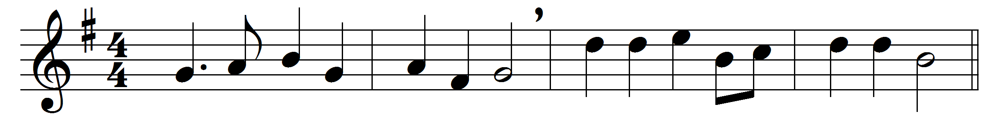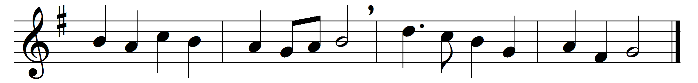

Hail the day that sees him rise,
to his throne above the skies;
Christ, the Lamb for sinners given,
enters now the highest heaven.

There for him high triumph waits;
lift your heads, eternal gates!
he hath conquered death and sin;
take the King of glory in!

Lo, the heaven its Lord receives,
yet he loves the earth he leaves;
though returning to his throne,
still he calls mankind his own.

See, he lifts his hands above;
see, he shews the prints of love;
hark, his gracious lips bestow
blessings on his Church below.

Still for us he intercedes,
his prevailing death he pleads;
near himself prepares our place,
he the first-fruits of our race.

Lord, though parted from our sight,
far above the starry height,
grant our hearts may thither rise,
seeking thee above the skies.

Words: Charles Wesley (1707-1788), Thomas Cotterill (1779-1823) and others
Music: Office of Pierre de Corbeil (d. 1222)

