Hail the day that sees him rise AMNS 87 Melody: Llanfair 7 7. 7 7. with Alleluias
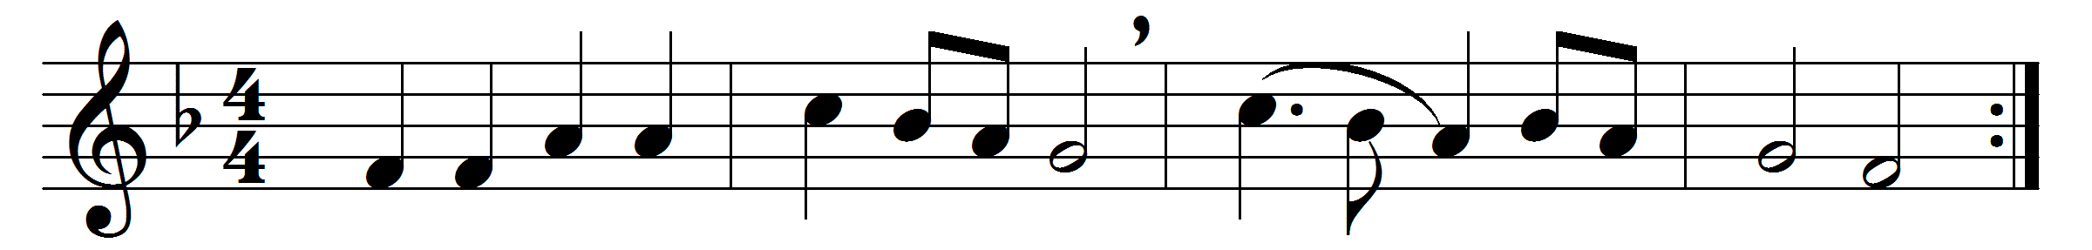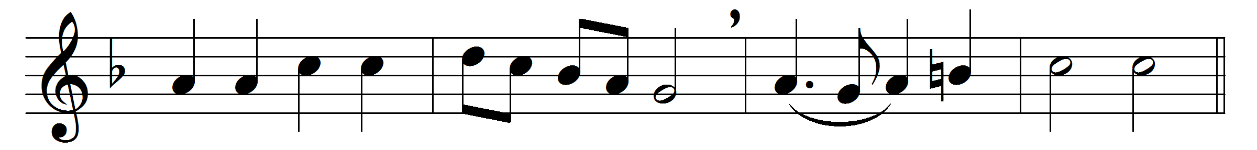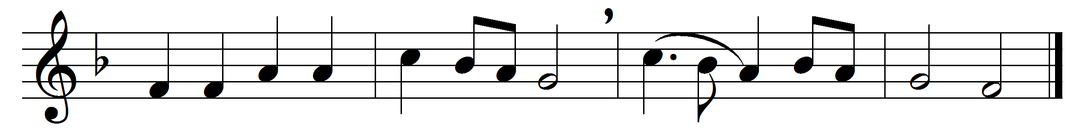

Hail the day that sees him rise, Alleluia.
to his throne above the skies; Alleluia.
Christ, the Lamb for sinners given, Alleluia.
enters now the highest heaven. Alleluia.
There for him high triumph waits; Alleluia.
lift your heads, eternal gates! Alleluia.
he hath conquered death and sin; Alleluia.
take the King of glory in! Alleluia.
Lo, the heaven its Lord receives, Alleluia.
yet he loves the earth he leaves; Alleluia.
though returning to his throne, Alleluia.
still he calls mankind his own. Alleluia.
See, he lifts his hands above; Alleluia.
see, he shews the prints of love; Alleluia.
hark, his gracious lips bestow Alleluia.
blessings on his Church below. Alleluia.

Still for us he intercedes, Alleluia.
his prevailing death he pleads; Alleluia.
near himself prepares our place, Alleluia.
he the first-fruits of our race. Alleluia.
Lord, though parted from our sight, Alleluia.
far above the starry height, Alleluia.
grant our hearts may thither rise, Alleluia.
seeking thee above the skies. Alleluia.

Words: Charles Wesley (1707-1788), Thomas Cotterill (1779-1823) and others
Music: Welsh hymn melody

