At the Lamb’s high feast we sing AMNS 81 Melody: Salzburg 7 7. 7 7. D.
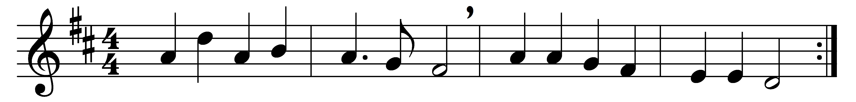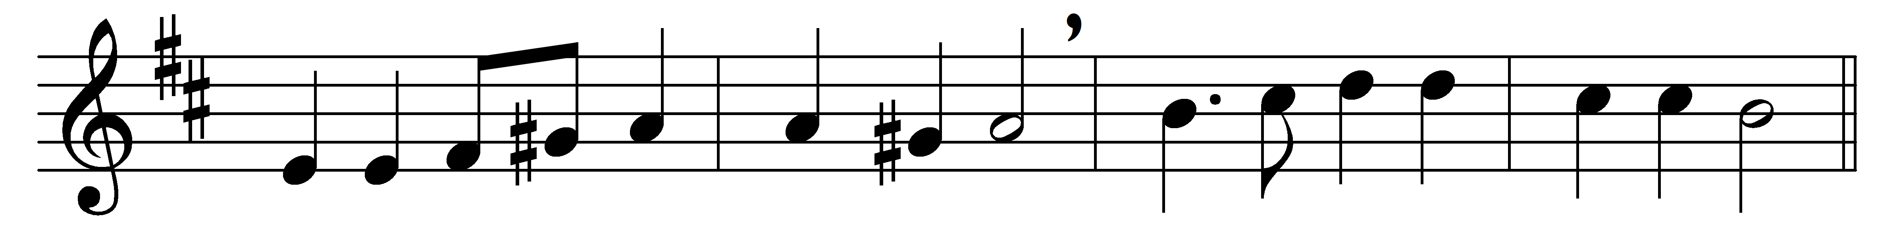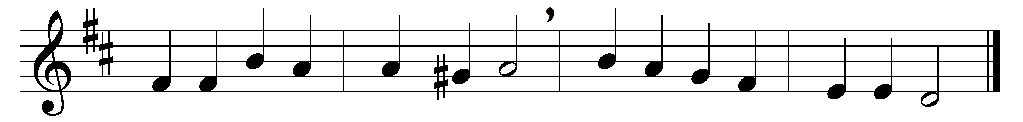

At the Lamb’s high feast we sing
praise to our victorious King,
who hath washed us in the tide
flowing from his piercèd side;
praise we him, whose love divine
gives his sacred blood for wine,
gives his body for the feast,
Christ the victim, Christ the priest.

Where the paschal blood is poured,
death’s dark angel sheathes his sword;
Israel’s hosts triumphant go
through the wave that drowns the foe.
Praise we Christ, whose blood was shed,
paschal victim, paschal bread;
with sincerity and love
eat we manna from above.

Mighty victim from the sky,
hell’s fierce powers beneath thee lie;
thou hast conquered in the fight,
thou hast brought us life and light.
Now no more can death appal,
now no more the grave enthral:
thou hast opened Paradise,
and in thee thy saints shall rise.

Easter triumph, Easter joy,
sin alone can this destroy;
from sin’s power do thou set free
souls new-born, O Lord, in thee.
Hymns of glory and of praise,
risen Lord, to thee we raise;
holy Father, praise to thee,
with the Spirit, ever be.

Words: Latin, translated by Robert Campbell (1814-1868)
Music: Jakob Hintze (1622-1702), harmonised by Johann Sebastian Bach (1685-1750)

