Alleluia, Alleluia AMNS 80 Melody: Lux Eoi 8 7. 8 7. D.
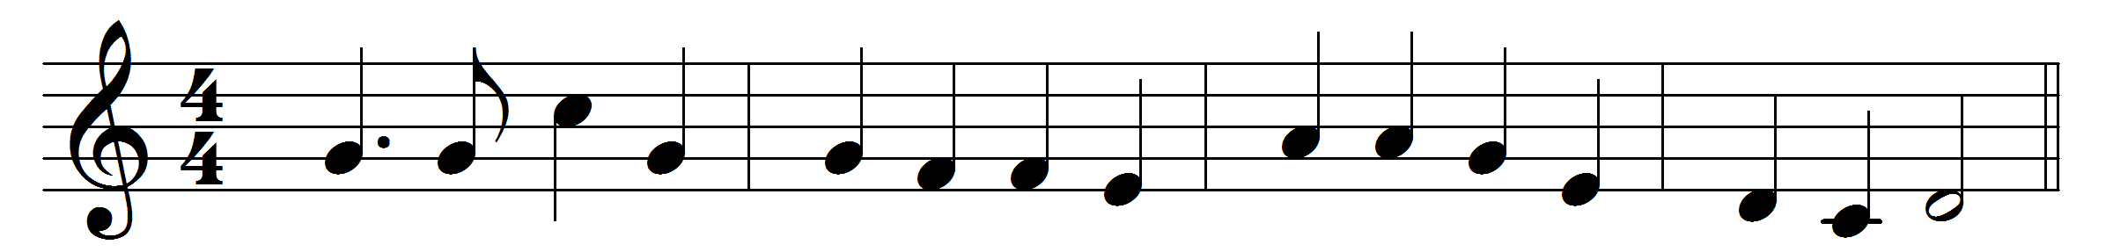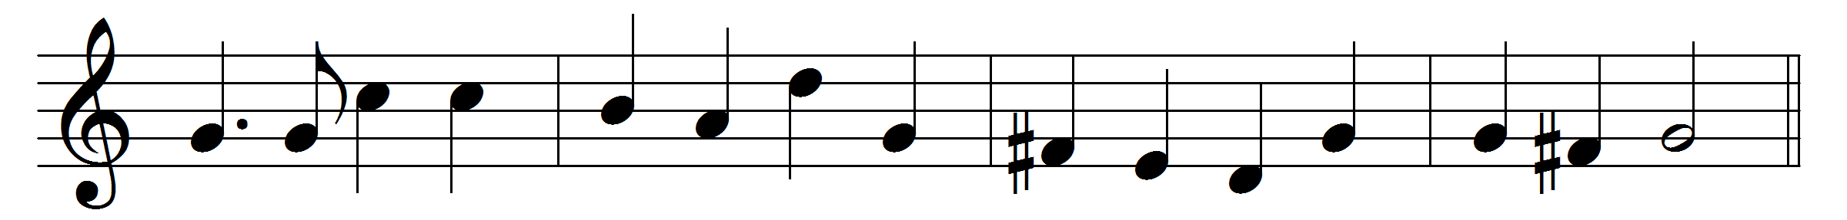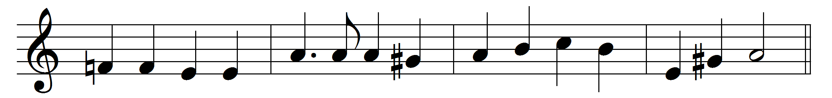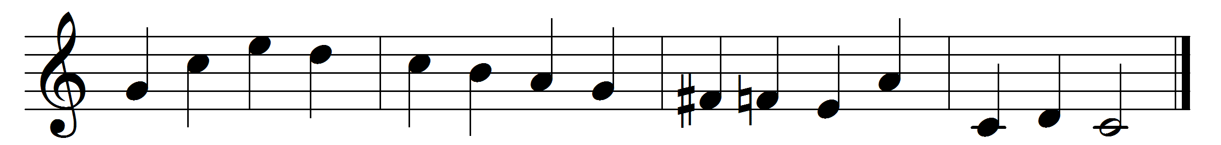

Alleluia, Alleluia,
hearts to heaven and voices raise;
sing to God a hymn of gladness,
sing to God a hymn of praise:
he who on the Cross a victim
for the world’s salvation bled,
Jesus Christ, the King of Glory,
now is risen from the dead.
Christ is risen, Christ the first-fruits
of the holy harvest field,
which will all its full abundance
at his second coming yield;
then the golden ears of harvest
will their heads before him wave,
ripened by his glorious sunshine,
from the furrows of the grave.
Christ is risen, we are risen;
shed upon us heavenly grace,
rain, and dew, and gleams of glory
from the brightness of thy face;
that we, with our hearts in heaven,
here on earth may fruitful be,
and by angel-hands be gathered,
and be ever, Lord, with thee.

Alleluia, Alleluia,
glory be to God on high;
Alleluia to the Saviour,
who has gained the victory;
Alleluia to the Spirit,
fount of love and sanctity;
Alleluia, Alleluia,
to the Triune Majesty.

Words: Christopher Wordsworth (1807-1885)
Music: Arthur Sullivan (1840-1901)

