O strength and stay AMNS 7 Melody: Strength and Stay 11 10. 11 10.
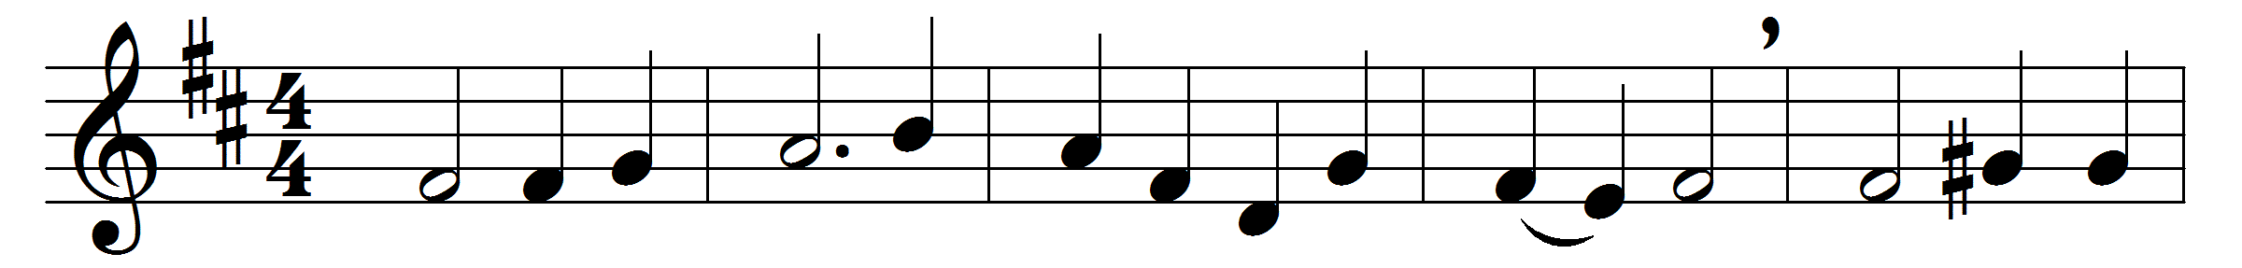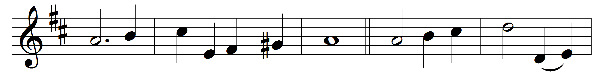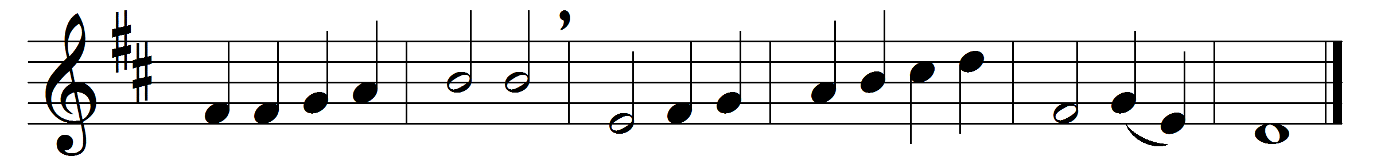

O strength and stay upholding all creation,
who ever dost thyself unmoved abide,
yet day by day the light in due gradation
from hour to hour through all its changes guide;

grant to life’s day a calm unclouded ending,
an eve untouched by shadows of decay,
the brightness of a holy death-bed blending
with dawning glories of the eternal day.

Hear us, O Father, gracious and forgiving,
through Jesus Christ thy co-eternal Word,
who with the Holy Ghost by all things living
now and to endless ages art adored.

Words: St. Ambrose (c. 340-397), translated by John Ellerton (1826-1893) and Fenton John Anthony Hort (1828-1892)
Music: John Bacchus Dykes (1823-1876)

