Christ the Lord is risen again AMNS 79 Melody: Württemberg 7 7. 7 7. with Alleluia
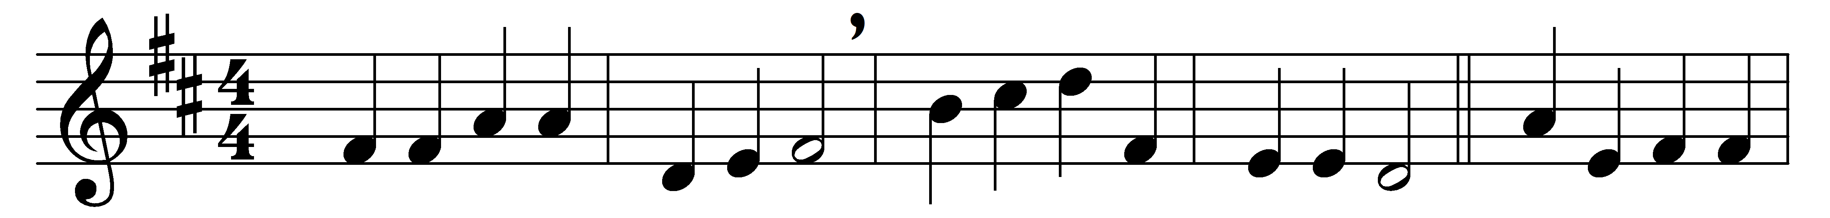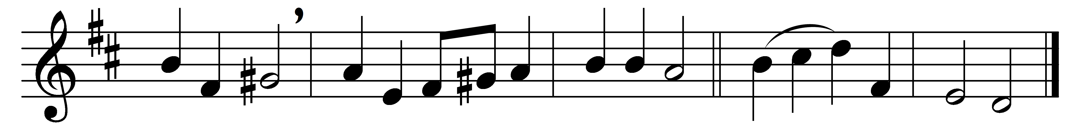

Christ the Lord is risen again,
Christ hath broken every chain.
Hark, angelic voices cry,
singing evermore on high, Alleluia.

He who gave for us his life,
who for us endured the strife,
is our paschal Lamb to-day;
we too sing for joy, and say Alleluia.

He who bore all pain and loss
comfortless upon the Cross,
lives in glory now on high,
pleads for us, and hears our cry: Alleluia.

He whose path no records tell,
who descended into hell,
who the strong man armed hath bound,
now in highest heaven is crowned. Alleluia.

He who slumbered in the grave
is exalted now to save;
now through Christendom it rings
that the Lamb is King of kings. Alleluia.

Now he bids us tell abroad
how the lost may be restored,
how the penitent forgiven,
how we too may enter heaven. Alleluia.

Thou, our paschal Lamb indeed,
Christ, thy ransomed people feed;
take our sins and guilt away:
let us sing by night and day Alleluia.

Words: Michael Weisse (c. 1480-1534), translated by Catherine Winkworth (1827-1878)
Music: Melody from Hundert Arien (Dresden, 1694)

