The strife is o’er AMNS 78 Melody: Gelobt sei Gott 8 8 8. with Alleluias

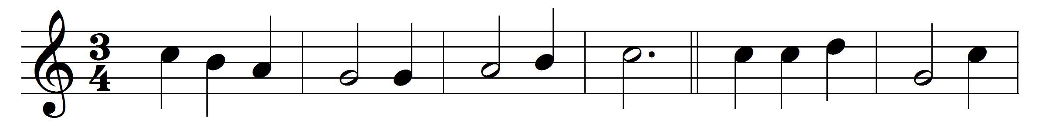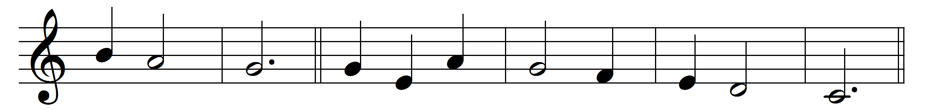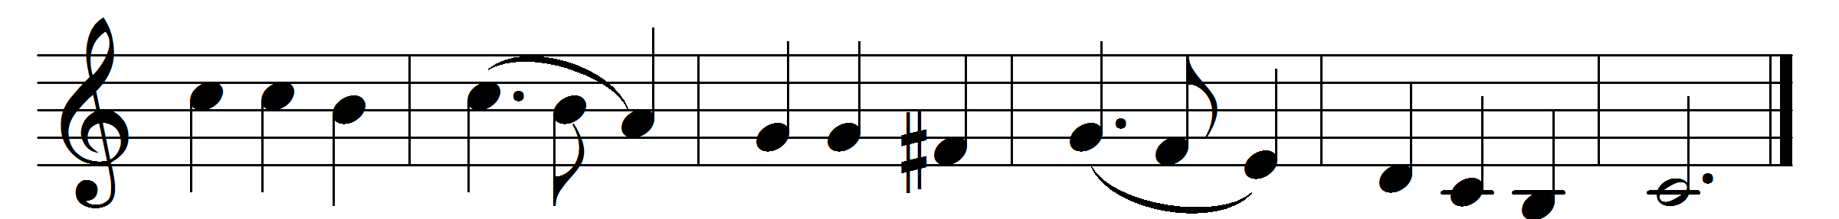

The strife is o’er, the battle done;
now is the Victor’s triumph won;
O let the song of praise be sung:
Alleluia.
Death’s mightiest powers have done their worst,
and Jesus hath his foes dispersed;
let shouts of praise and joy outburst:
Alleluia.
On the third morn he rose again
glorious in majesty to reign;
O let us swell the joyful strain:
Alleluia.
Lord, by the stripes which wounded thee
from death’s dread sting thy servants free,
that we may live, and sing to thee
Alleluia.

Words: Latin, ? 17th century, translated by Francis Pott (1832-1909)
Music: Melody from Melchior Vulpius (Gesangbuch, 1609)

