Jesus Christ is risen today AMNS 77 Melody: Easter Hymn 7 7. 77. with Alleluias
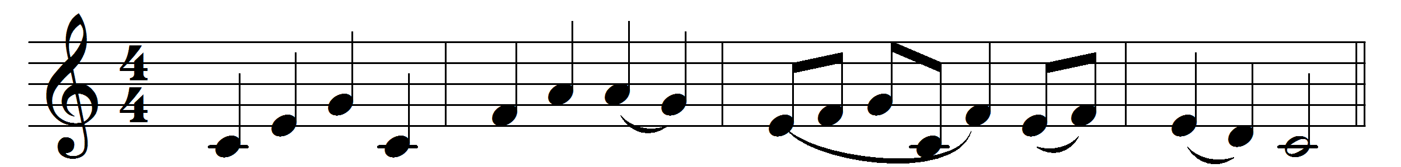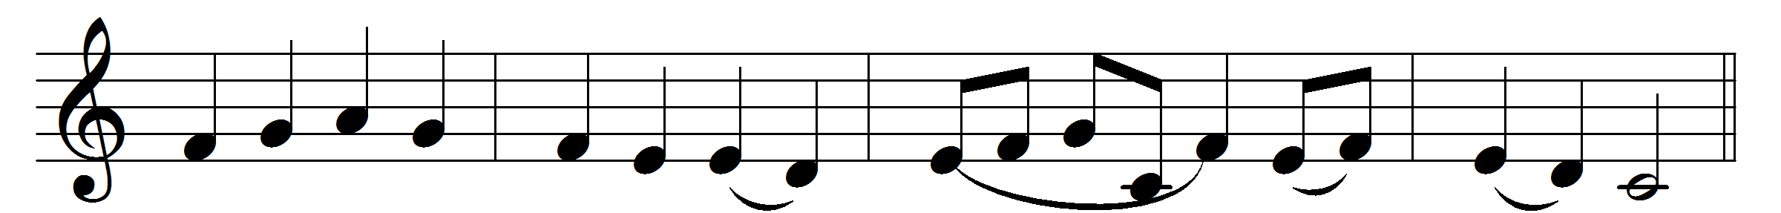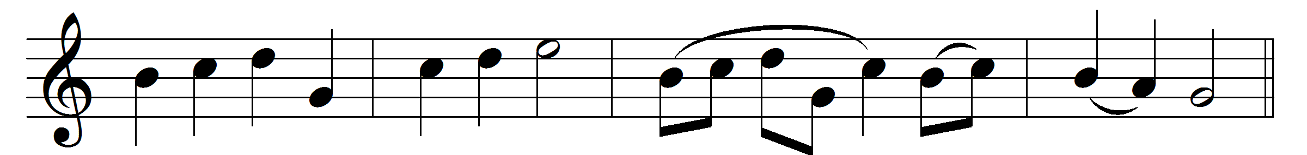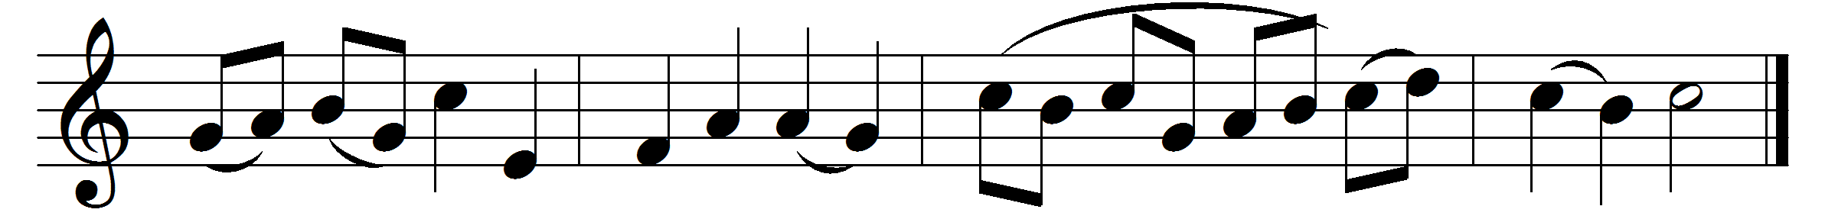

Jesus Christ is risen to-day, Alleluia.
our triumphant holy day, Alleluia.
who did once, upon the cross, Alleluia.
suffer to redeem our loss. Alleluia.

Hymns of praise then let us sing, Alleluia.
unto Christ our heavenly King, Alleluia.
who endured the cross and grave, Alleluia.
sinners to redeem and save. Alleluia.
But the pains that he endured, Alleluia.
our salvation have procured; Alleluia.
now above the sky he’s King, Alleluia.
where the angels ever sing. Alleluia.

Words: Lyra Davidica (1708) and others
Music: Lyra Davidica (1708) (later version)

