The day of resurrection! AMNS 75 Melody: Ellacombe 7 6. 7 6. D.

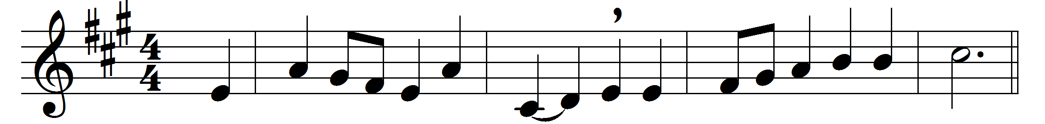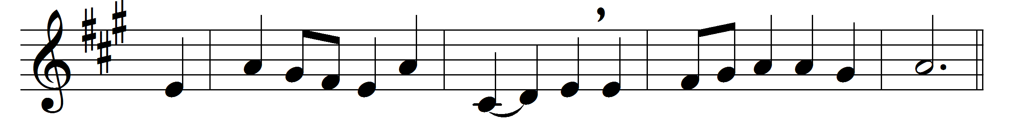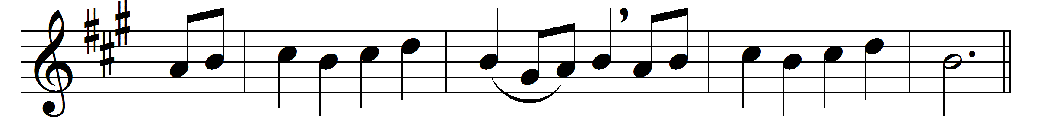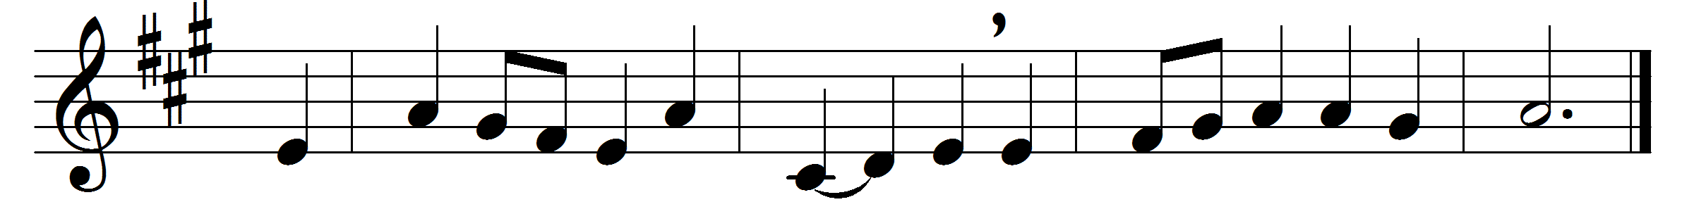

The day of resurrection!
earth, tell it out abroad;
the Passover of gladness,
the Passover of God;
from death to life eternal,
from earth unto the sky,
our God hath brought us over
with hymns of victory.

Our hearts be pure from evil,
that we may see aright
the Lord in rays eternal
of resurrection-light;
and, listening to his accents,
may hear so calm and plain
his own ‘All hail,’ and, hearing,
may raise the victor strain.
Now let the heavens be joyful,
and earth her song begin,
the round world keep high triumph,
and all that is therein;
let all things seen and unseen
their notes of gladness blend,
for Christ the Lord is risen,
our joy that hath no end.

Words: St. John of Damascus (d. c. 754), translated by John Mason Neale (1818-1866)
Melody from Württemberg Gesangbuch, 1784

