It is a thing most wonderful AMNS 70 Melody: Alstone L.M.

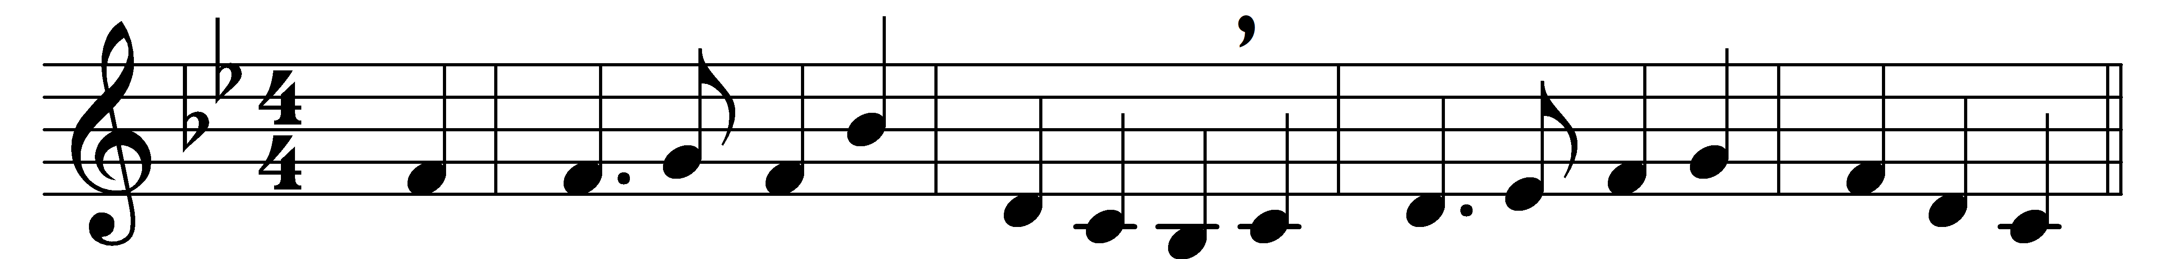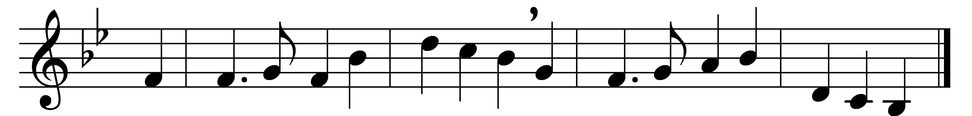

It is a thing most wonderful,
almost too wonderful to be,
that God’s own Son should come from heaven,
and die to save a child like me.

And yet I know that it is true:
he chose a poor and humble lot,
and wept and toiled and mourned and died
for love of those who loved him not.

I cannot tell how he could love
a child so weak and full of sin;
his love must be most wonderful,
if he could die my love to win.

I sometimes think about the Cross,
and shut my eyes, and try to see
the cruel nails and crown of thorns,
and Jesus crucified for me.

But even could I see him die,
I could but see a little part
of that great love which, like a fire,
is always burning in his heart.

It is most wonderful to know
his love for me so free and sure;
but ’tis more wonderful to see
my love for him so faint and poor.

And yet I want to love thee, Lord;
O light the flame within my heart,
and I will love thee more and more,
until I see thee as thou art.

Words: William Walsham How (1823-1897)
Music: Christopher Edwin Willing (1830-1904)

