At the cross her station keeping AMNS 69 Melody: Stabat Mater 8 8 7.

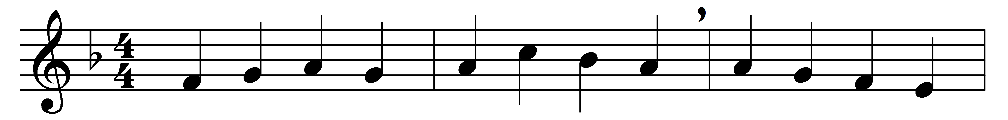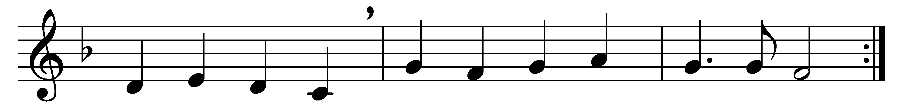

At the cross her station keeping
stood the mournful Mother weeping,
where he hung, the dying Lord;
for her soul, of joy bereavèd,
bowed with anguish, deeply grievèd,
felt the sharp and piercing sword.

O how sad and sore distressèd
now was she, that Mother blessèd
of the sole-begotten one!
Deep the woe of her affliction,
when she saw the crucifixion
of her ever-glorious Son.

Who, on Christ’s dear Mother gazing
pierced by anguish so amazing,
born of woman, would not weep?
who, on Christ’s dear Mother thinking
such a cup of sorrow drinking,
would not share her sorrows deep?

For his people’s sins chastisèd,
she beheld her Son despisèd,
scourged, and crowned with thorns entwined;
saw him then from judgement taken,
and in death by all forsaken,
till his spirit he resigned.

O good Jesu, let me borrow
something of thy Mother’s sorrow,
fount of love, Redeemer kind,
that my heart fresh ardour gaining,
and a purer love attaining,
may with thee acceptance find.

Words: Ascribed to Jacopone da Todi (d. 1306), translated by Edward Caswall (1814-1878)
Music: Adapted from Mayntzisch Gesangbuch, 1661

