My God, I love thee; not because AMNS 65 Melody: St. Francis Xavier C.M.
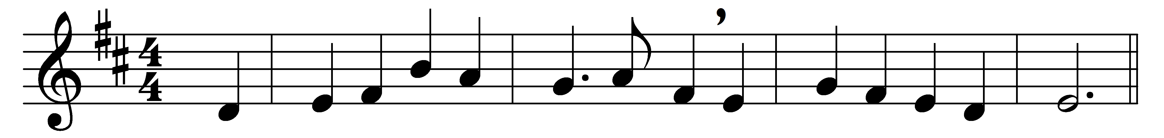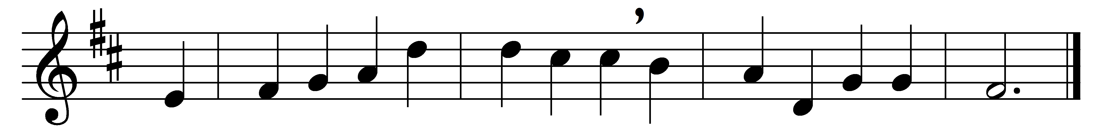

My God, I love thee; not because
I hope for heaven thereby,
nor yet because who love thee not
are lost eternally.

Thou, O my Jesus, thou didst me
upon the cross embrace;
for me didst bear the nails and spear,
and manifold disgrace,

and griefs and torments numberless,
and sweat of agony;
yea, death itself – and all for me
who was thine enemy.

Then why, O blessèd Jesu Christ,
should I not love thee well?
not for the sake of winning heaven,
nor of escaping hell;

not from the hope of gaining aught,
not seeking a reward;
but as thyself hast lovèd me,
O ever-loving Lord.

So would I love thee, dearest Lord,
and in thy praise will sing;
solely because thou art my God,
and my most loving King.

Words: Latin, 17th century, translated by Edward Caswall (1814-1878)
Music: John Stainer (1840-1901)

