All ye who seek for sure relief AMNS 64 Melody: St. Bernard C.M.
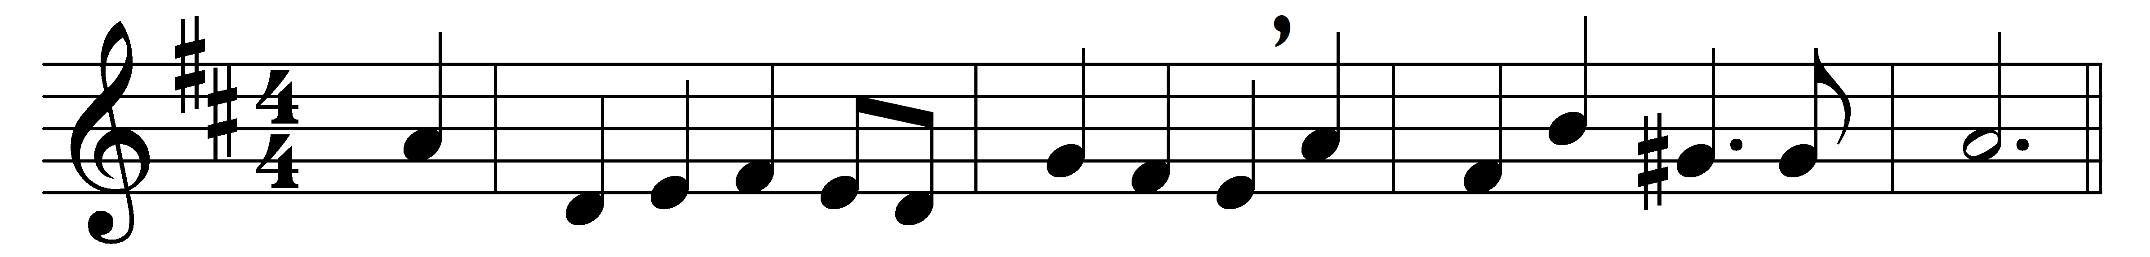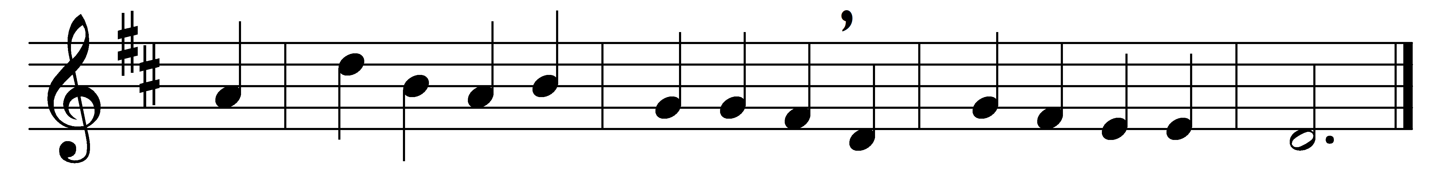

All ye who seek for sure relief
in trouble and distress,
whatever sorrow vex the mind,
or guilt the soul oppress,

Jesus, who gave himself for you
upon the cross to die,
opens to you his sacred heart:
O to that heart draw nigh.

Ye hear how kindly he invites;
ye hear his words so blest:
‘All ye that labour come to me,
and I will give you rest.’

O Jesus, joy of saints on high,
thou hope of sinners here,
attracted by those loving words
to thee we lift our prayer.

Wash thou our wounds in that dear blood
which from thy heart doth flow;
a new and contrite heart on all
who cry to thee bestow.

Words: Latin, 18th century, translated by Edward Caswall (1814-1878)
Music: Adapted from Tochter Sion (Cologne, 1741)

