Ride on triumphantly! Behold, we lay AMNS 62 Melody: Farley Castle 10 10. 10 10.
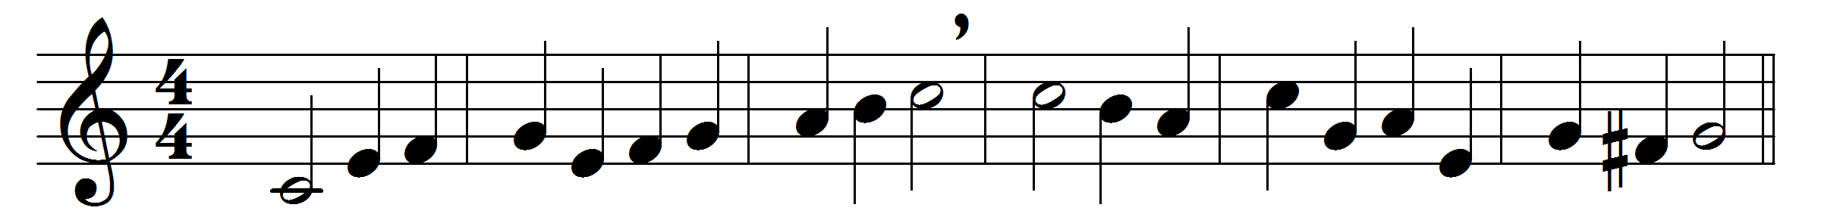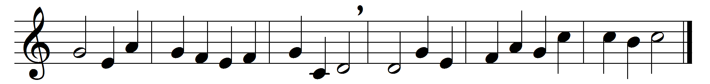

Ride on triumphantly! Behold, we lay
our lusts and sins and proud wills in thy way:
thy road is ready, and thy paths made straight
with longing expectation seem to wait.

Hosanna! Welcome to our hearts! for here
thou hast a temple too, as Sion dear:
enter, O Lord, and cleanse that holy place
where thou dost choose to set thy beauteous face.
Words: Adapted from Jeremy Taylor (1613-1667)
Music: Melody and bass by Henry Lawes (1596-1662)

