Sing, my tongue, the glorious battle AMNS 59 Melody: St. Thomas 8 7. 8 7. 8 7.
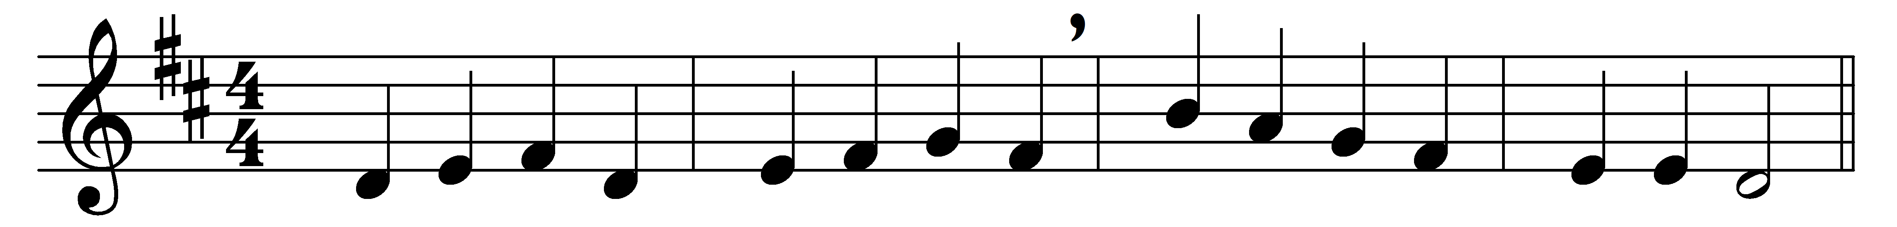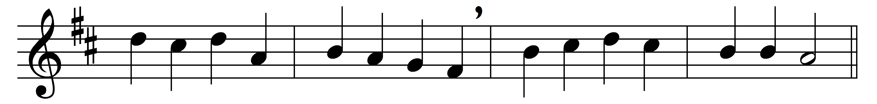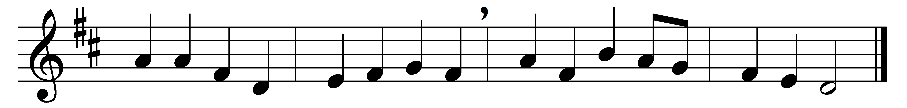

Part 1
Sing, my tongue, the glorious battle,
sing the last, the dread affray;
o’er the Cross, the victor’s trophy,
sound the high triumphal lay,
how, the pains of death enduring,
earth’s Redeemer won the day.

When at length the appointed fulness
of the sacred time was come,
he was sent, the world’s creator,
from the Father’s heavenly home,
and was found in human fashion,
offspring of the Virgin’s womb.

Now the thirty years are ended
which on earth he willed to see,
willingly he meets his Passion,
born to set his people free;
on the Cross the Lamb is lifted,
there the sacrifice to be.

There the nails and spear he suffers,
vinegar and gall and reed;
from his sacred body piercèd
blood and water both proceed:
precious flood, which all creation
from the stain of sin hath freed.

Part 2
Faithful Cross, above all other,
one and only noble tree,
none in foliage, none in blossom,
none in fruit thy peer may be;
sweet the wood, and sweet the iron,
and thy load, most sweet is he.

Bend, O lofty tree, thy branches,
thy too rigid sinews bend;
and awhile the stubborn hardness,
which thy birth bestowed, suspend;
and the limbs of heaven’s high Monarch
gently on thine arms extend.

Thou alone wast counted worthy
this world’s ransom to sustain,
that a shipwrecked race for ever
might a port of refuge gain,
with the sacred blood anointed
of the Lamb for sinners slain.

Doxology
Praise and honour to the Father,
praise and honour to the Son,
praise and honour to the Spirit,
ever Three and ever One:
One in might, and One in glory,
while eternal ages run.

Words: Venantius Fortunatus (c. 530-c. 600), translated by John Mason Neale (1818-1866)
Music: Traditional melody (18th century)

