My spirit longs for thee AMNS 57 Melody: Eccles 66. 66.
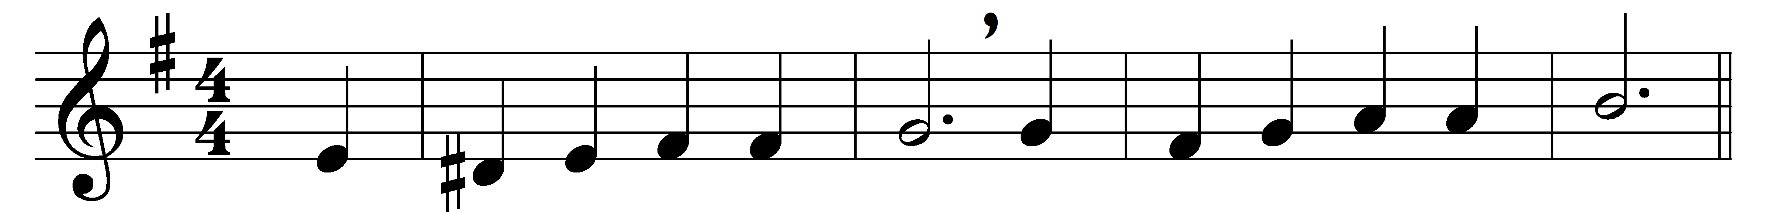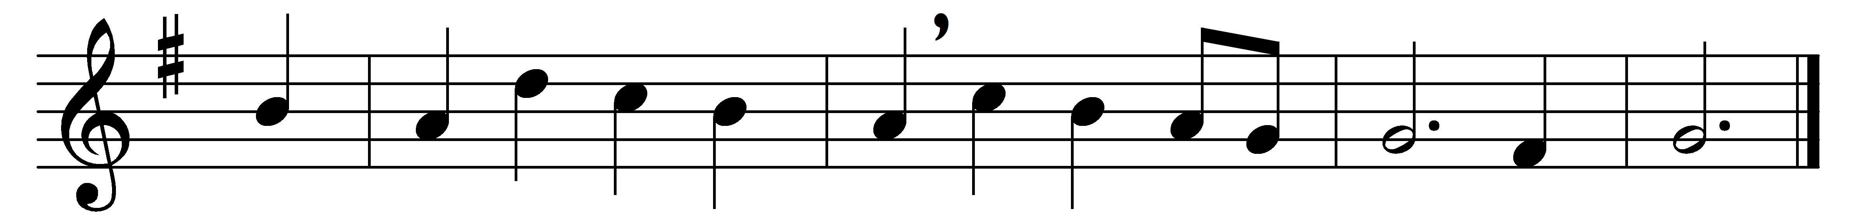

My spirit longs for thee
within my troubled breast,
though I unworthy be
of so divine a guest.

Of so divine a guest
unworthy though I be,
yet has my heart no rest
unless it come from thee.

Unless it come from thee,
in vain I look around;
in all that I can see
no rest is to be found.

No rest is to be found
but in thy blessèd love:
O let my wish be crowned,
and send it from above!

Words: John Byrom (1692-1763)
Music: Bertram Luard Selby (1853-1918)

