Christian, dost thou see them AMNS 55 Melody: St. Andrew of Crete 6 5. 6 5. D.
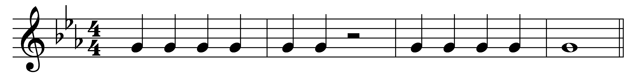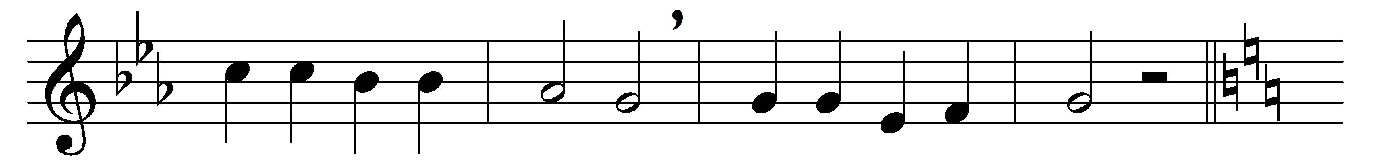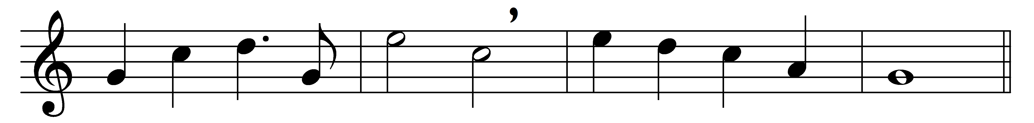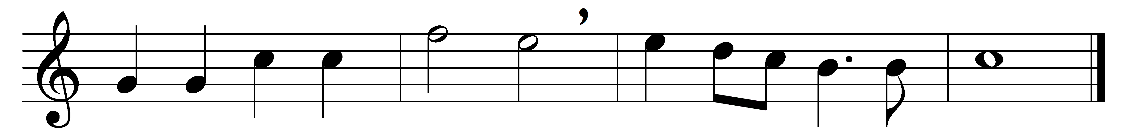

Christian, dost thou see them
on the holy ground,
how the troops of Midian
prowl and prowl around?
Christian, up and smite them,
counting gain but loss;
smite them by the merit
of the holy Cross.

Christian, dost thou feel them,
how they work within,
striving, tempting, luring,
goading into sin?
Christian, never tremble;
never be down-cast;
smite them by the virtue
of the Lenten fast.

Christian, dost thou hear them,
how they speak thee fair?
‘Always fast and vigil?
Always watch and prayer?’
Christian, answer boldly,
‘While I breathe I pray:’
peace shall follow battle,
night shall end in day.

‘Well I know thy trouble,
O my servant true;
thou art very weary,
I was weary too;
but that toil shall make thee
some day all mine own,
and the end of sorrow
shall be near my throne.’

Words: John Mason Neale (1818-1866)
Music: John Bacchus Dykes (1823-1876)

