Songs of thankfulness and praise AMNS 53 Melody: St. Edmund 7 7. 7 7. D.
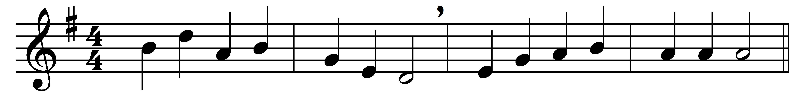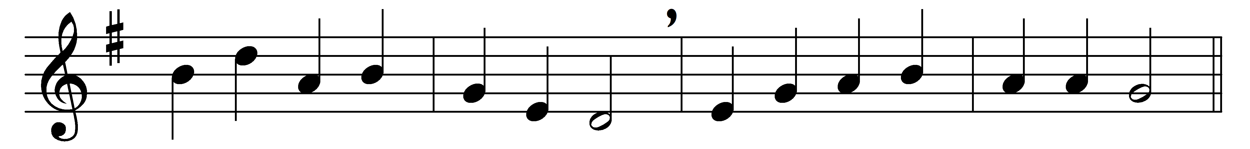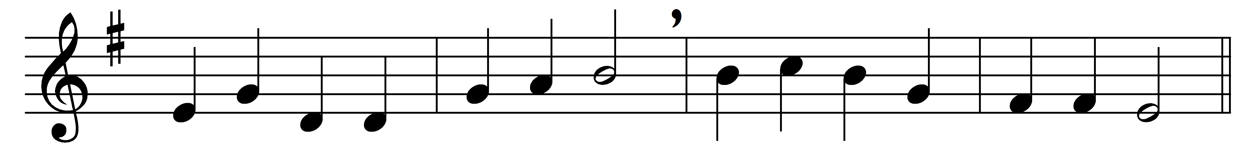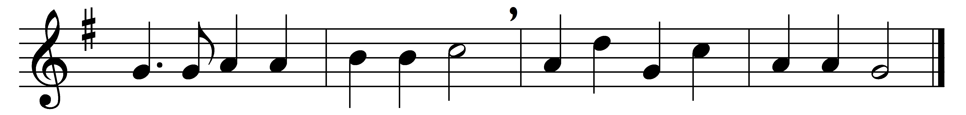

Songs of thankfulness and praise,
Jesu, Lord, to thee we raise,
manifested by the star
to the sages from afar;
branch of royal David’s stem
in thy birth at Bethlehem:
anthems be to thee addrest,
God in Man made manifest.

Manifest at Jordan’s stream,
Prophet, Priest, and King supreme;
and at Cana wedding-guest
in thy Godhead manifest;
manifest in power divine,
changing water into wine:
anthems be to thee addrest,
God in Man made manifest.

Manifest in making whole
palsied limbs and fainting soul;
manifest in valiant fight;
quelling all the devil’s might;
manifest in gracious will,
ever bringing good from ill:
anthems be to thee addrest,
God in Man made manifest.

Sun and moon shall darkened be,
stars shall fall, the heavens shall flee;
Christ will then like lightning shine,
all will see his glorious sign;
all will then the trumpet hear,
all will see the Judge appear:
thou by all wilt be confest,
God in Man made manifest.

Grant us grace to see thee, Lord,
mirrored in thy holy word;
may we imitate thee now,
and be pure, as pure art thou;
that we like to thee may be
at thy great Epiphany;
and may praise thee, ever blest,
God in Man made manifest.

Words: Christopher Wordsworth (1807-1885)
Music: Charles Steggall (1826-1905)

