Ye watchers and ye holy ones AMNS 532
Melody: Lasst uns erfreuen (Easter Song) 8 8. 4 4. 8 8. and Alleluias

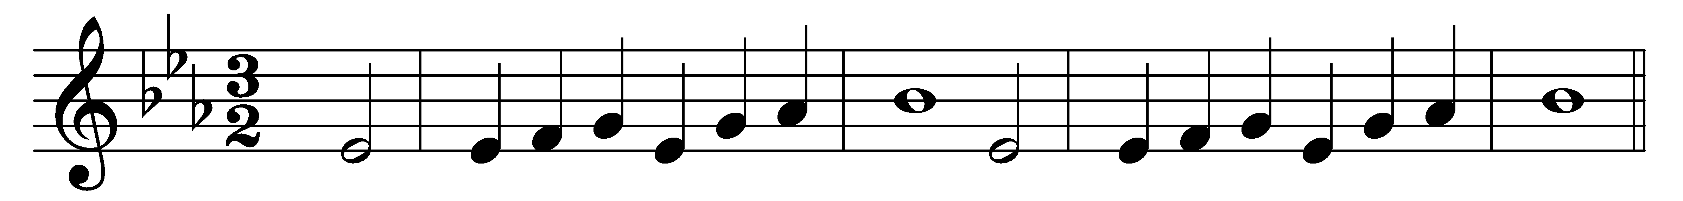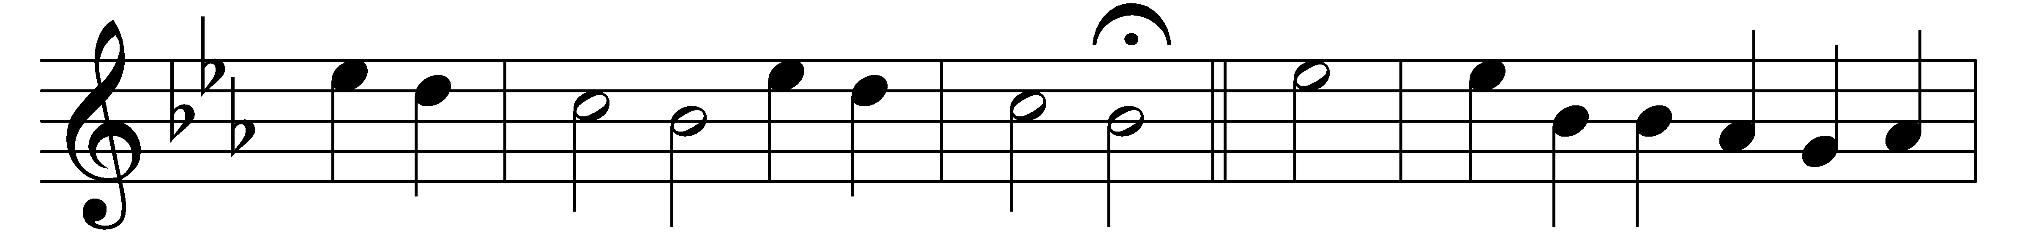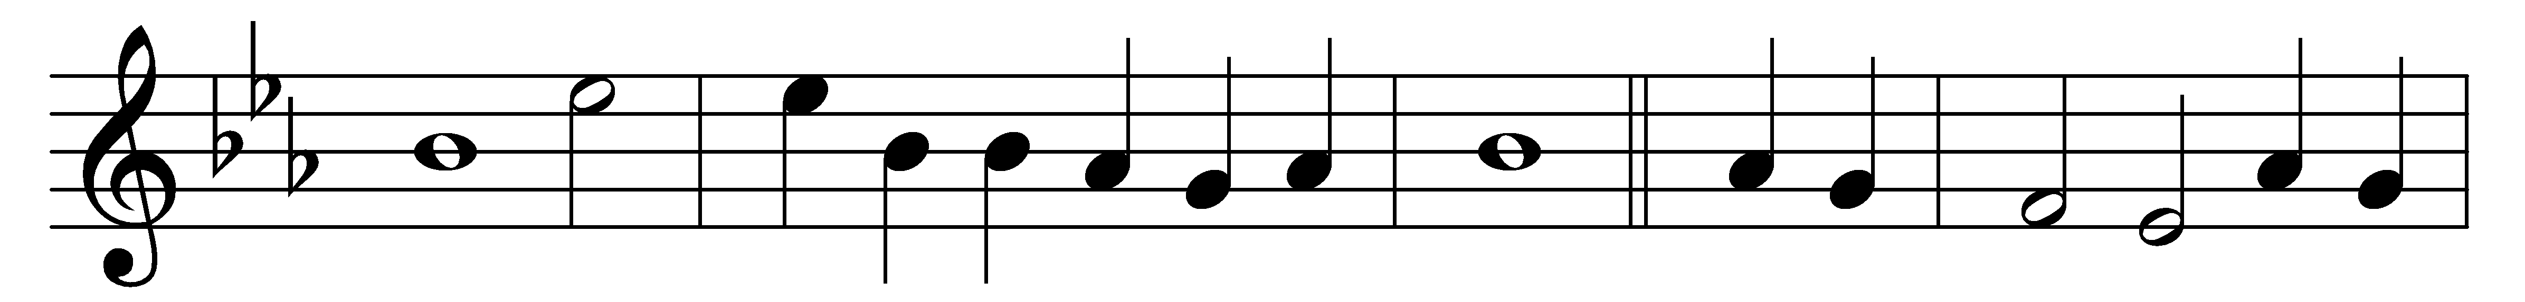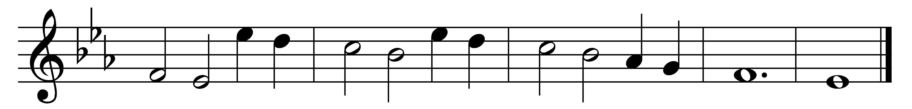

Ye watchers and ye holy ones,
bright Seraphs, Cherubim and Thrones,
raise the glad strain, Alleluia.
Cry out, Dominions, Princedoms, Powers,
Virtues, Archangels, Angels’ choirs,
Alleluia, alleluia, alleluia.

O higher than the Cherubim,
more glorious than the Seraphim,
lead their praises, Alleluia.
Thou Bearer of the eternal Word,
most gracious, magnify the Lord.
Alleluia, alleluia, alleluia.

Respond, ye souls in endless rest,
ye Patriarchs and Prophets blest,
Alleluia, alleluia.
Ye holy Twelve, ye Martyrs strong,
all Saints triumphant, raise the song
Alleluia, alleluia, alleluia.

O friends, in gladness let us sing,
supernal anthems echoing,
Alleluia, alleluia.
To God the Father, God the Son,
and God the Spirit, Three in One,
Alleluia, alleluia, alleluia.

Words: Athelstan Riley (1858-1945)
Music: Melody from Geistliche Kirchengesäng, Cologne, 1623

