With joy we meditate the grace AMNS 530 Melody: Salzburg C.M.
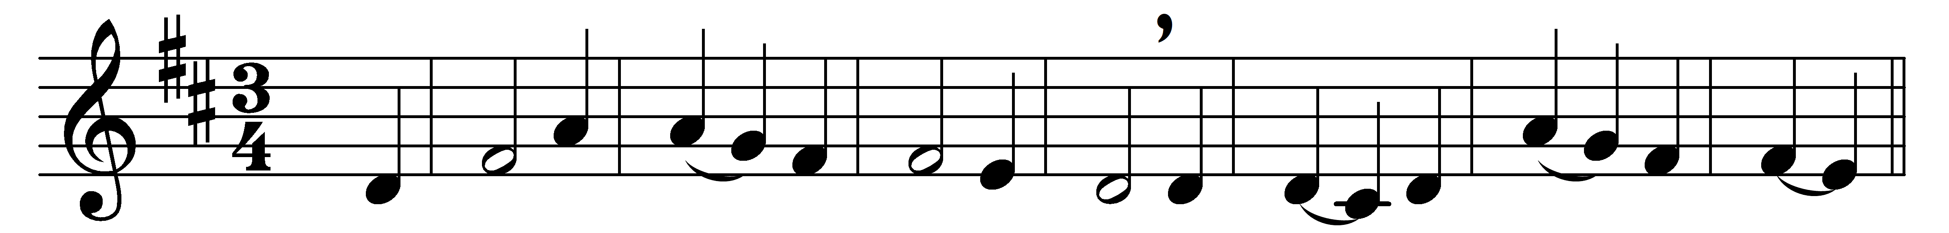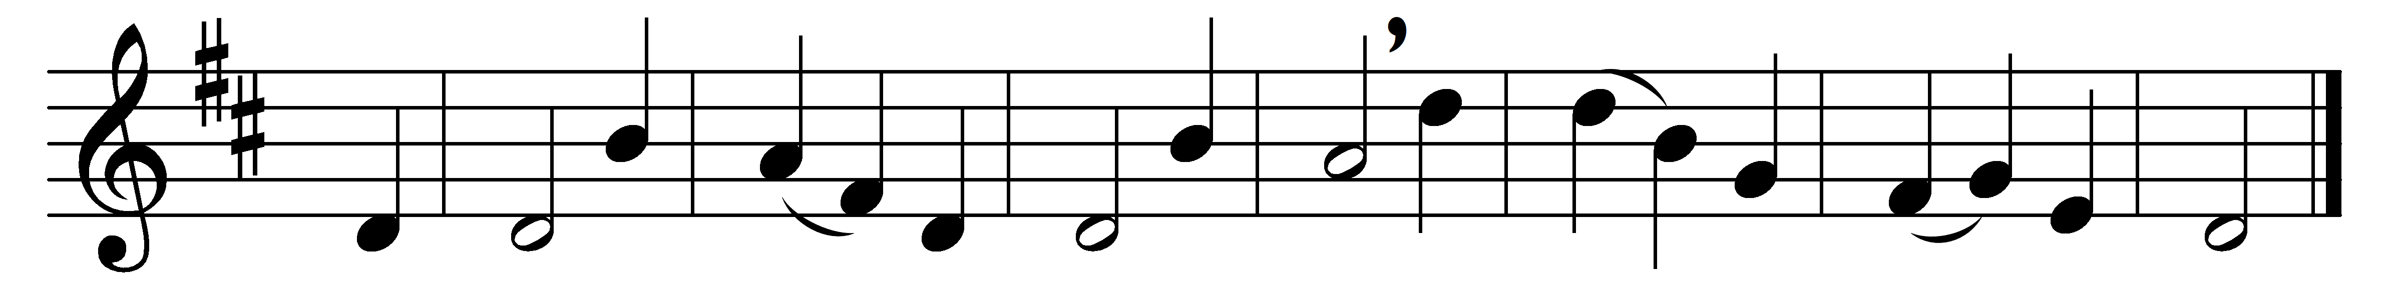

With joy we meditate the grace
of our High Priest above;
his heart is made of tenderness,
and ever yearns with love.

Touched with a sympathy within,
he knows our feeble frame;
he knows what sore temptations mean
for he has felt the same.

He in the days of feeble flesh
poured out his cries and tears;
and, in his measure, feels afresh
what every member bears.

He’ll never quench the smoking flax,
but raise it to a flame;
the bruisèd reed he never breaks,
nor scorns the meanest name.

Then let our humble faith address
his mercy and his power:
we shall obtain delivering grace
in every needful hour.

Words: Isaac Watts (1674-1748)
Music: Melody adapted from Michael Haydn (1737-1806)

