The people that in darkness sat AMNS 52 Melody: Dundee C.M.
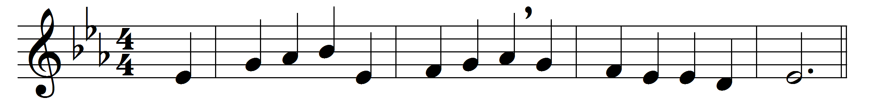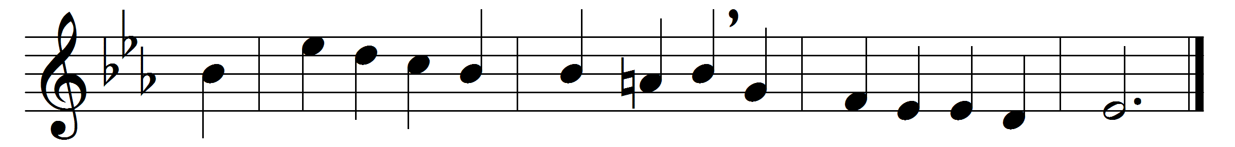

The people that in darkness sat
a glorious light have seen;
the light has shined on them who long
in shades of death have been.

To hail thee, Sun of Righteousness,
the gathering nations come;
they joy as when the reapers bear
their harvest treasures home.

For thou their burden dost remove,
and break the tyrant’s rod,
as in the day when Midian fell
before the sword of God.

For unto us a Child is born,
to us a Son is given,
and on his shoulder ever rests
all power in earth and heaven.

His name shall be the Prince of Peace,
the everlasting Lord,
the Wonderful, the Counsellor,
the God by all adored.

His righteous government and power
shall over all extend;
on judgement and on justice based,
his reign shall have no end.

Lord Jesus, reign in us, we pray,
and make us thine alone,
who with the Father ever art
and Holy Spirit One.

Words: John Morison (1750-1798)
Music: Melody from Psalms (Edinburgh, 1615)

