Where is this stupendous stranger? AMNS 527 Melody: Halton Holgate 8 7. 8 7.
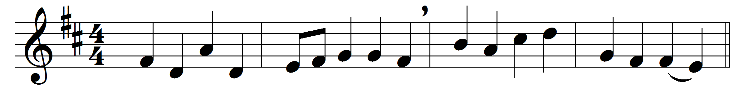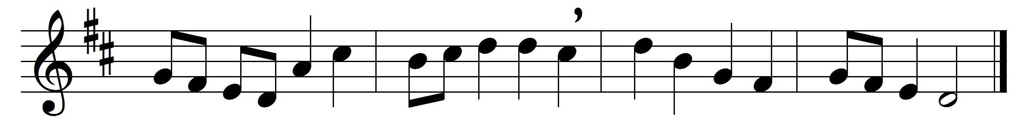

Where is this stupendous stranger?
prophets, shepherds, kings, advise:
lead me to my Master’s manger,
show me where my Saviour lies.
O most mighty, O most holy,
far beyond the seraph’s thought,
art thou then so mean and lowly
as unheeded prophets taught?
O the magnitude of meekness,
worth from worth immortal sprung,
O the strength of infant weakness,
if eternal is so young.
God all-bounteous, all-creative,
whom no ills from good dissuade,
is incarnate, and a native
of the very world he made.

Words: Christopher Smart (1722-1771)
Music: Later form of melody by William Boyce (c. 1710-1779)

