We give immortal praise AMNS 520 Melody: Croft’s 136th 6 6. 6 6. 4 4. 4 4.
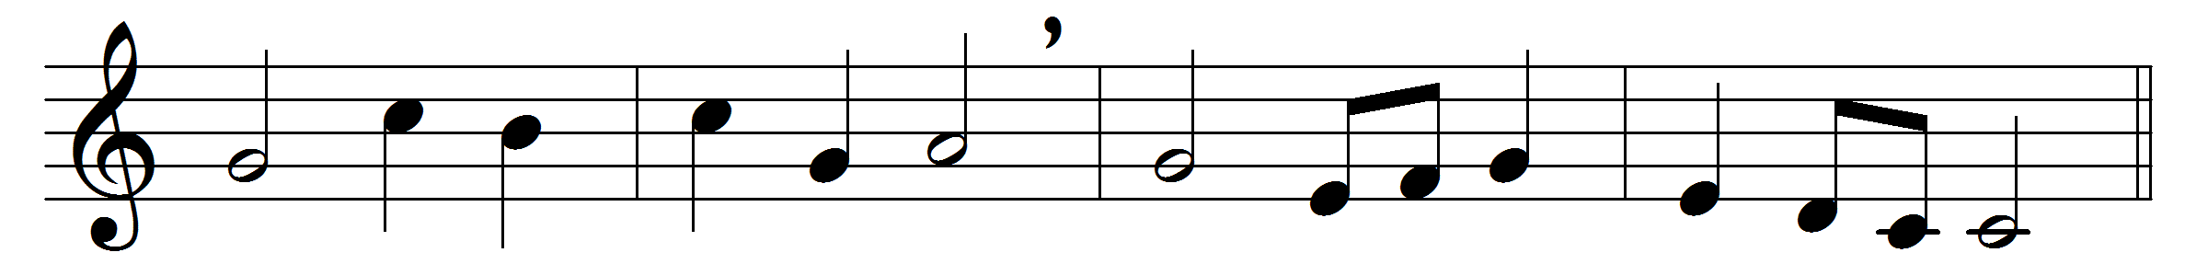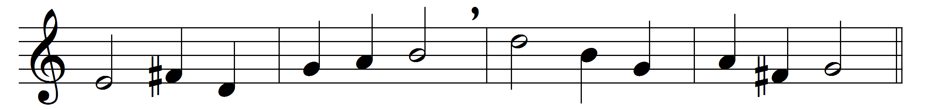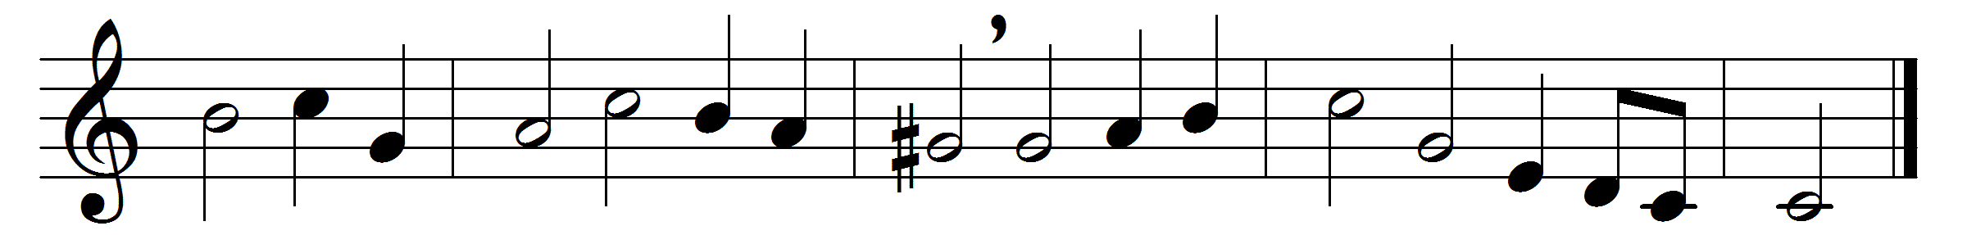

We give immortal praise
to God the Father’s love
for all our comforts here,
and better hopes above:
he sent his own
eternal Son,
to die for sins
that man had done.

To God the Son belongs
immortal glory too,
who bought us with his blood
from everlasting woe:
and now he lives,
and now he reigns,
and sees the fruit
of all his pains.

To God the Spirit’s name
immortal worship give,
whose new-creating power
makes the dead sinner live:
his work completes
the great design,
and fills the soul
with joy divine.

Almighty God, to thee
be endless honours done,
the undivided Three,
and the mysterious One:
where reason fails
with all her powers,
there faith prevails,
and love adores.

Words: Isaac Watts (1674-1748)
Music: Melody and bass by William Croft (1678-1727)

