The heavenly Child in stature grows AMNS 50 Melody: Tallis’s Ordinal C.M.
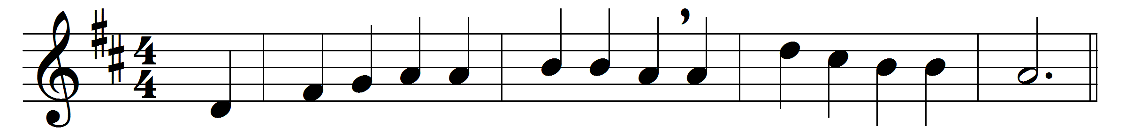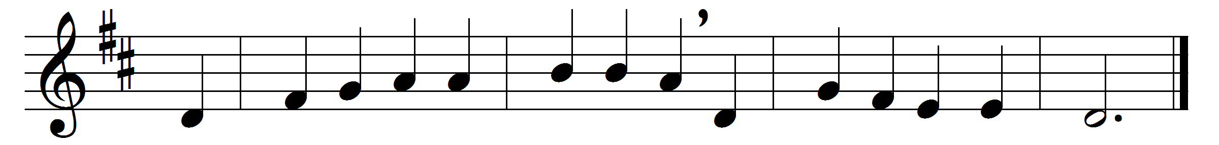

The heavenly Child in stature grows,
and, growing, learns to die;
and still his early training shows
his coming agony.

The Son of God his glory hides
to dwell with parents poor;
and he who made the heavens abides
in dwelling-place obscure.

Those mighty hands that rule the sky
no earthly toil refuse;
the maker of the stars on high
an humble trade pursues.

He whom the choirs of angels praise,
bearing each dread decree,
his earthly parents now obeys
in glad humility.

For this thy lowliness revealed,
Jesus, we thee adore,
and praise to God the Father yield
and Spirit evermore.

Words: Jean-Baptiste de Santeuil (1630-1697), translated by John Chandler (1806-1876)
Music: Thomas Tallis (c. 1505-1585)

