Christ, whose glory fills the skies AMNS 4 Melody: Ratisbon 7 7. 7 7. 7 7.
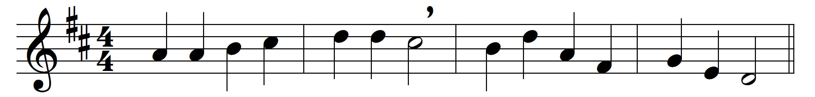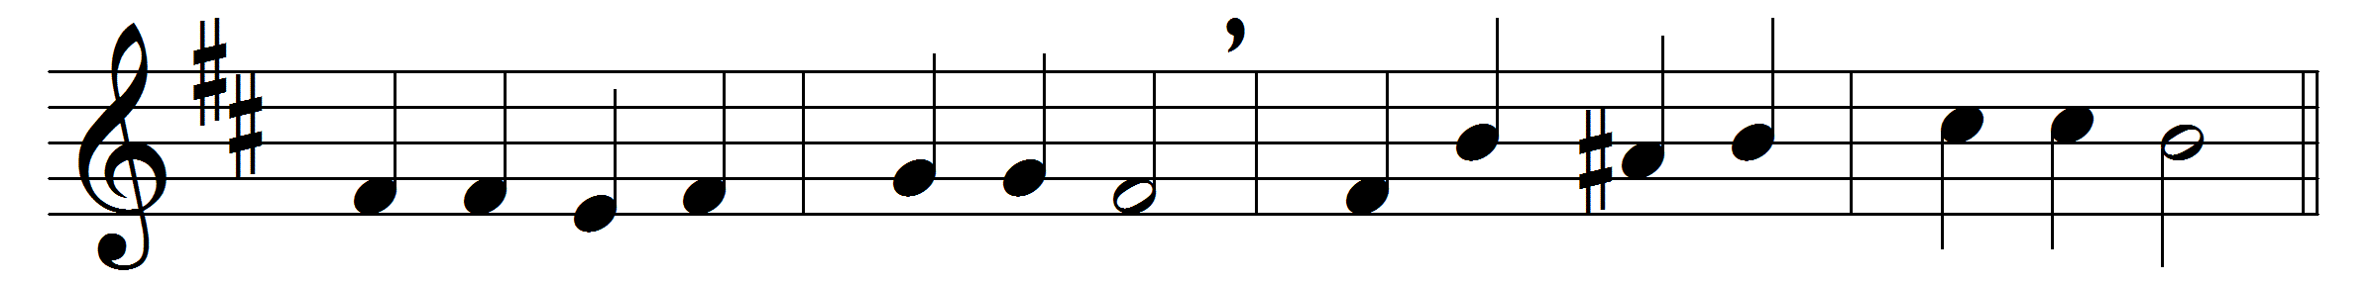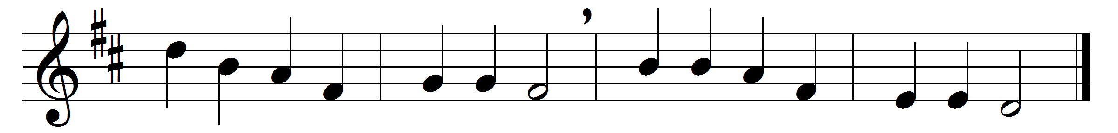

Christ, whose glory fills the skies,
Christ, the true, the only light,
Sun of Righteousness, arise,
triumph o’er the shades of night;
Dayspring from on high, be near;
Daystar, in my heart appear.
Dark and cheerless is the morn
unaccompanied by thee;
joyless is the day’s return,
till thy mercy’s beams I see,
till they inward light impart,
glad my eyes, and warm my heart.
Visit then this soul of mine,
pierce the gloom of sin and grief;
fill me, radiancy divine,
scatter all my unbelief;
more and more thyself display,
shining to the perfect day.

Words: Charles Wesley (1707-1788)
Music: Melody from Werner’s Choralbuch (Leipzig, 1815)

