Now from the altar of our hearts AMNS 499 Melody: Glasgow C.M.
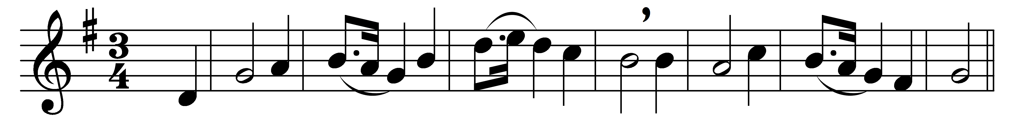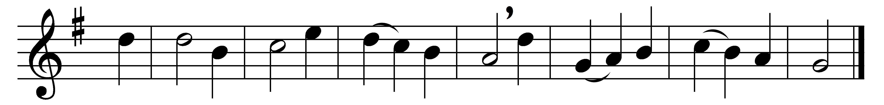

Now from the altar of our hearts
let incense flames arise;
assist us, Lord, to offer up
our morning sacrifice.
Awake, my love; awake, my joy;
awake, my heart and tongue.
Sleep not: when mercies loudly call,
break forth into a song.
This day be God our sun and shield,
our keeper and our guide;
his care be on our frailty shown,
his mercies multiplied.
New time, new favour, and new joys
a new song all require;
till we shall praise thee as we would,
accept our hearts’ desire.

Words: John Mason (c. 1645-1694)
Music: Moore’s Psalm-Singer’s Pocket Companion, 1756

