Earth has many a noble city AMNS 48 Melody: Stuttgart 8 7. 8 7.
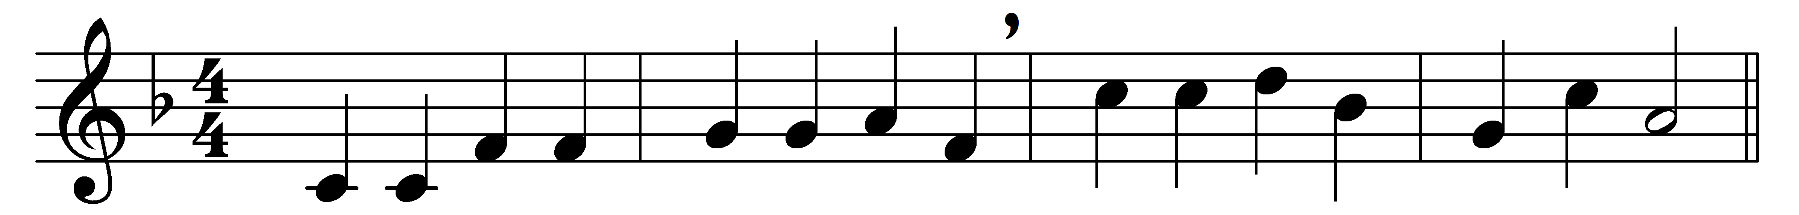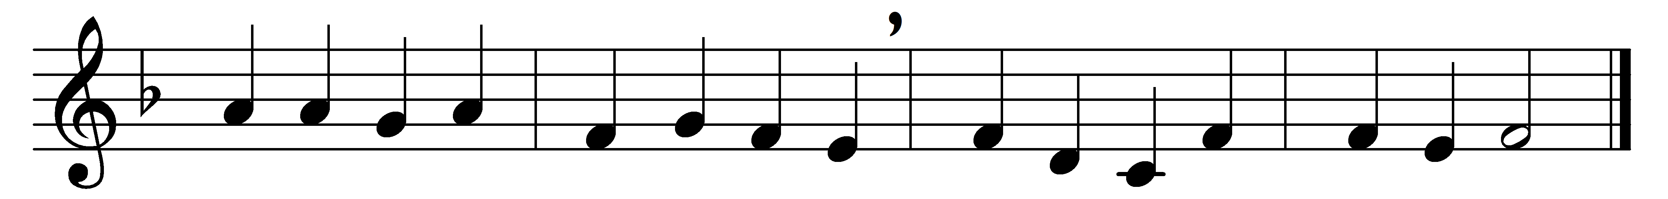

Earth has many a noble city;
Bethl’em, thou dost all excel:
out of thee the Lord from heaven
came to rule his Israel.

Fairer than the sun at morning
was the star that told his birth,
to the world its God announcing
seen in fleshly form on earth.

Eastern sages at his cradle
make oblations rich and rare;
see them give in deep devotion
gold and frankincense and myrrh.

Sacred gifts of mystic meaning:
incense doth their God disclose,
gold the King of kings proclaimeth,
myrrh his sepulchre foreshows.

Jesu, whom the Gentiles worshipped
at thy glad Epiphany,
unto thee with God the Father
and the Spirit glory be.

Words: Prudentius (348-c. 413), translated by Edward Caswall (1814-1878)
Music: Adapted from a melody by Christian Friedrich Witt (1660-1716)

