To us a Child of royal birth AMNS 45 Melody: Invitation (Devonshire) L.M.
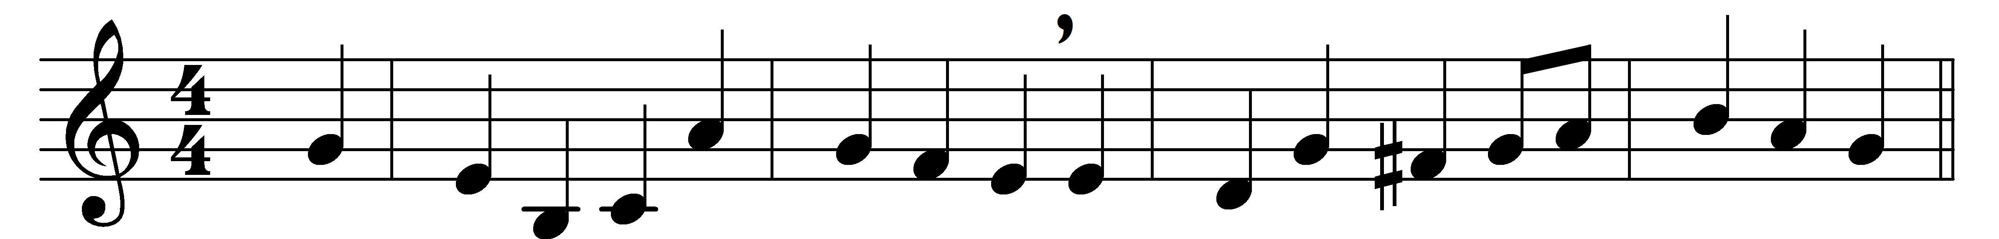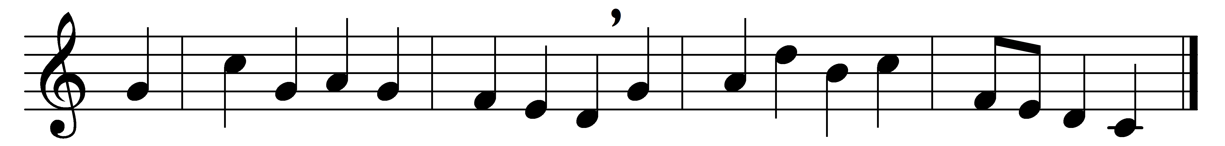

To us a Child of royal birth,
heir of the promises, is given;
th’ invisible appears on earth,
the Son of Man, the God of Heaven.

A Saviour born, in love supreme,
he comes our fallen souls to raise;
he comes his people to redeem,
with all the fulness of his grace.

The Christ, by raptured seers foretold,
filled with th’ eternal Spirit’s power,
Prophet, and Priest, and King behold,
and Lord of all the worlds adore.

The Lord of Hosts, the God most high,
who quits his throne on earth to live,
with joy we welcome from the sky,
with faith into our hearts receive.

Words: Charles Wesley (1707-1788)
Music: Melody by John Frederick Lampe (1703-1751)

