For the bread which you have broken AMNS 456 Melody: Waltham 8 7. 8 7.
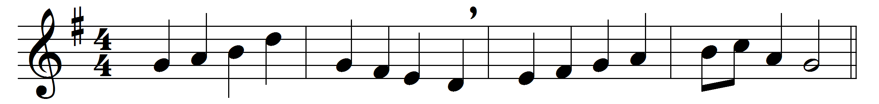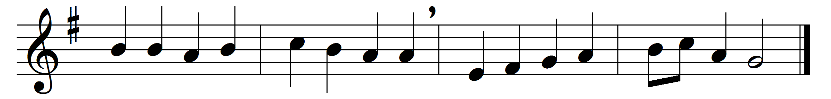

For the bread which you have broken,
for the wine which you have poured,
for the words which you have spoken,
now we give you thanks, O Lord.
By these pledges that you love us,
by your gift of peace restored,
by your call to heaven above us,
hallow all our lives, O Lord.
In your service, Lord, defend us,
in our hearts keep watch and ward;
in the world to which you send us
let your kingdom come, O Lord.

Words: Louis FitzGerald Benson (1855-1930)
Music: Melody by Heinrich Albert (1604-1651), harmony adapted from Johann Sebastian Bach (1685-1750)

