Behold, the great Creator makes AMNS 44 Melody: Kilmarnock C.M.
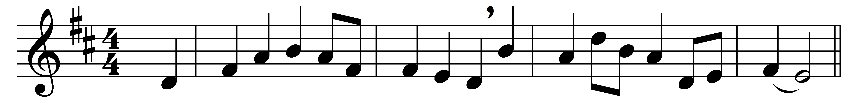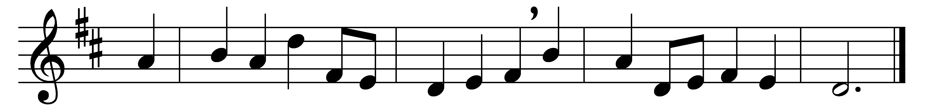

Behold, the great Creator makes
himself a house of clay,
a robe of virgin flesh he takes
which he will wear for ay.

Hark, hark! the wise eternal Word
like a weak infant cries;
in form of servant is the Lord,
and God in cradle lies.

This wonder struck the world amazed,
it shook the starry frame;
squadrons of spirits stood and gazed,
then down in troops they came.

Glad shepherds ran to view this sight;
a choir of angels sings,
and eastern sages with delight
adore this King of kings.

Join then, all hearts that are not stone,
and all our voices prove,
to celebrate this Holy One,
the God of peace and love.

Words: Thomas Pestel (1585-1659)
Music: Neil Dougall (1776-1862)

