Come, Holy Ghost, our hearts inspire AMNS 448 Melody: Nun danket all C.M.
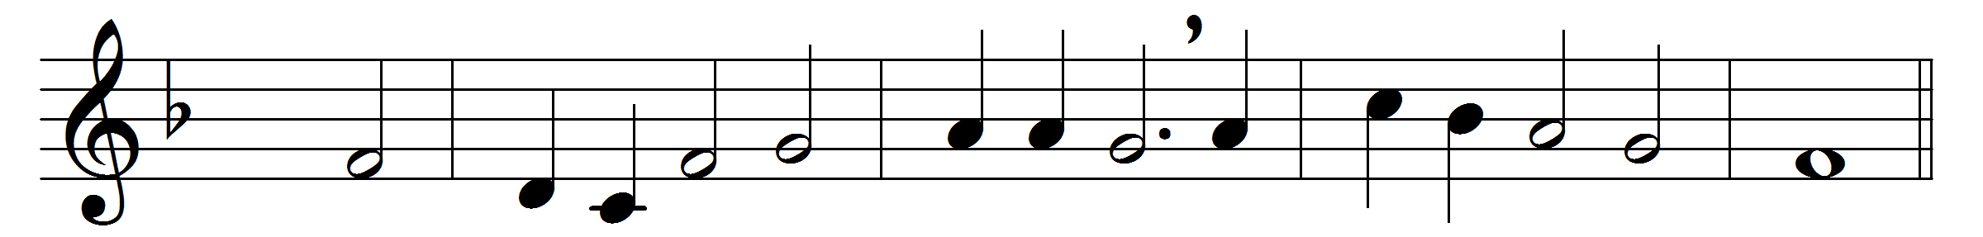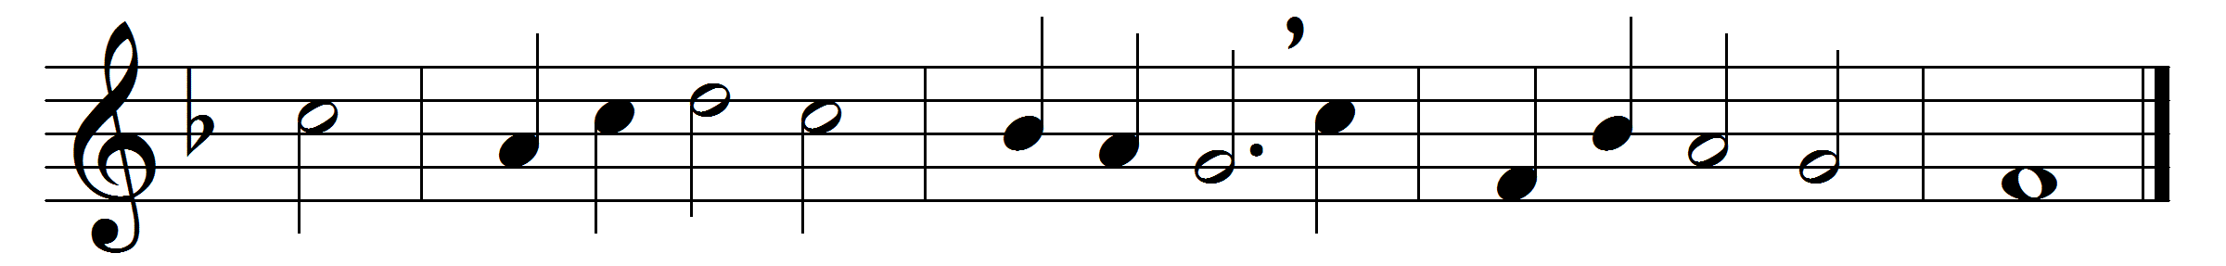

Come, Holy Ghost, our hearts inspire,
let us thine influence prove;
source of the old prophetic fire,
fountain of life and love.

Come, Holy Ghost – for, moved by thee,
thy prophets wrote and spoke –
unlock the truth, thyself the key,
unseal the sacred book.

Expand thy wings, celestial Dove,
brood o’er our nature’s night;
on our disordered spirits move,
and let there now be light.

God, through himself, we then shall know,
if thou within us shine;
and sound, with all thy saints below,
the depths of love divine.

Words: Charles Wesley (1707-1788)
Music: Melody from Praxis pietatis melica, 1647

