A great and mighty wonder AMNS 43 Melody: Es ist ein’ Ros’ 7 6. 7 6. 6 7 6.

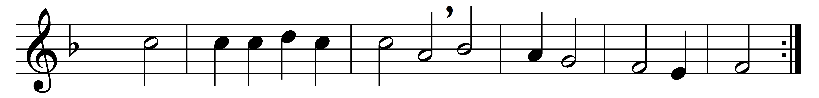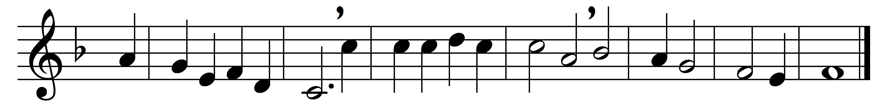

A great and mighty wonder,
a full and holy cure!
the Virgin bears the Infant
with virgin-honour pure:
(Refrain:) Repeat the hymn again
‘To God on high be glory,
and peace on earth to men.’

The Word becomes incarnate,
and yet remains on high;
and cherubim sing anthems
to shepherds from the sky:
Refrain

While thus they sing your Monarch,
those bright angelic bands,
rejoice, ye vales and mountains,
ye oceans, clap your hands:
Refrain

Since all he comes to ransom,
by all be he adored,
the infant born in Bethl’em,
the Saviour and the Lord:
Refrain

Words: St. Germanus (c. 634-c. 734), translated by John Mason Neale (1818-1866)
Music: German carol melody, harmony based on Michael Praetorius (1571-1621)

