Away with gloom, away with doubt AMNS 437 Melody: Blairgowrie 8 8. 8 6. 8 6.
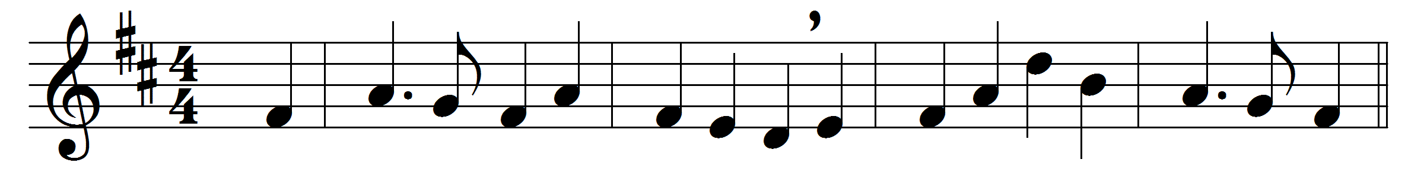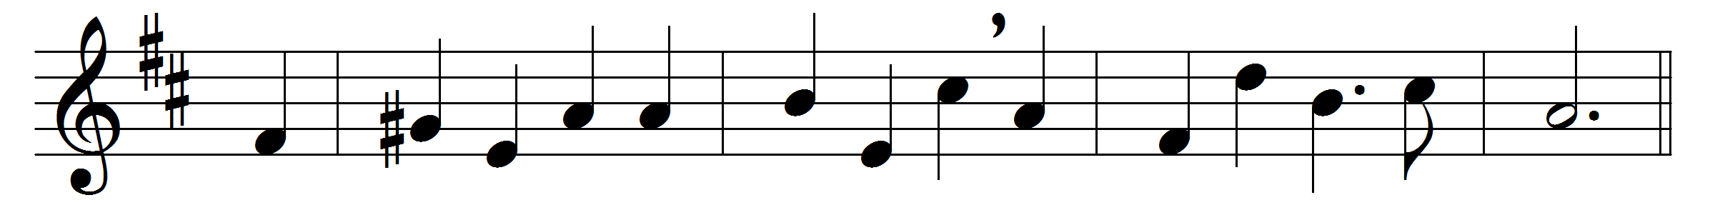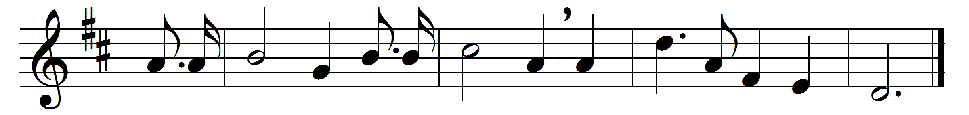

Away with gloom, away with doubt,
with all the morning stars we sing;
with all the sons of God we shout
the praises of a King,
Alleluia, alleluia,
of our returning King.
Away with death, and welcome life;
in him we died and live again:
and welcome peace, away with strife,
for he returns to reign.
Alleluia, alleluia,
the Crucified shall reign.
Then welcome beauty, he is fair;
and welcome youth, for he is young;
and welcome spring; and everywhere
let merry songs be sung,
Alleluia, alleluia,
for such a King be sung.

Words: Edward Shillito (1872-1948)
Music: Robert George Thompson (1862-1934)

