In the bleak mid-winter AMNS 42 Melody: Cranham Irregular metre
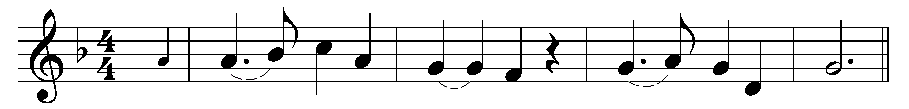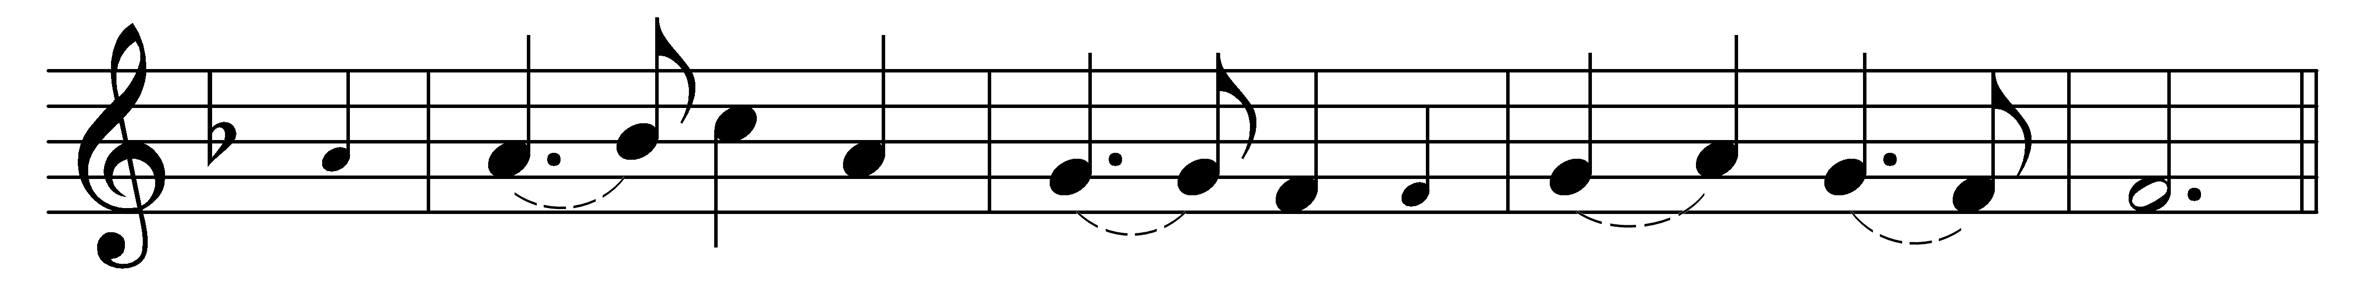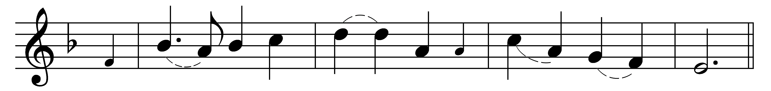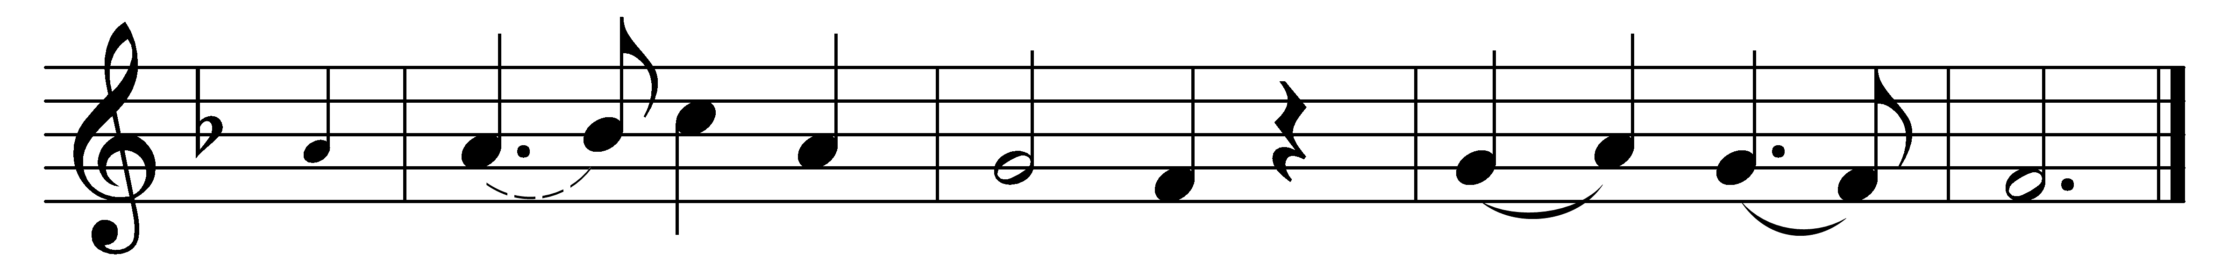

In the bleak mid-winter
frosty wind made moan,
earth stood hard as iron,
water like a stone:
snow had fallen, snow on snow,
snow on snow,
in the bleak mid-winter,
long ago.

Our God, heaven cannot hold him
nor earth sustain;
heaven and earth shall flee away
when he comes to reign:
in the bleak mid-winter
a stable-place sufficed
the Lord God Almighty,
Jesus Christ.

Enough for him, whom cherubim
worship night and day,
a breastful of milk
and a mangerful of hay:
enough for him, whom angels
fall down before,
the ox and ass and camel
which adore.

Angels and archangels
may have gathered there,
cherubim and seraphim
thronged the air –
but only his mother
in her maiden bliss
worshipped the Belovèd
with a kiss.

What can I give him,
poor as I am?
if I were a shepherd
I would bring a lamb;
if I were a wise man
I would do my part;
yet what I can I give him –
give my heart.

Words: Christina Georgina Rossetti (1830-1894)
Music: Gustav Holst (1874-1934)

