Upon thy table, Lord, we place AMNS 429 Melody: Brockham L.M.
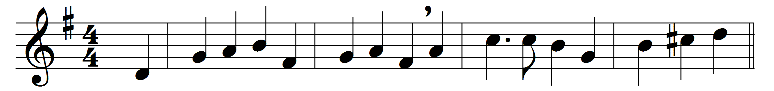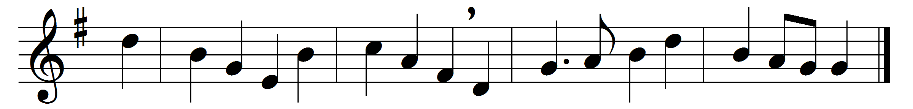

Upon thy table, Lord, we place
these symbols of our work and thine,
life’s food won only by thy grace,
who giv’st to all the bread and wine.
Within these simple things there lie
the height and depth of human life,
the thought of man, his tears and toil,
his hopes and fears, his joy and strife.
Accept them, Lord; from thee they come:
we take them humbly at thy hand.
These gifts of thine for higher use
we offer, as thou dost command.

Words: Maurice Frank Campbell Willson (1884-1944)
Music: Jeremiah Clarke (c. 1673-1707)

